**Class:-**

We have learned about the simple data types like int, Boolean, char etc. So if we want to create complex custom types, then we go with class. Complex type means if we want to store an Employee number then we use int variable for store the employee number. If we want to store the employee information then we use the complex type like class.

A class consists of data and behavior .Class data is represented by its field and behavior is represented by its method.

**Note:-1-**If we declare any variable as static then we cannot access that variable using this keyword.

**2-**Static modifier is not allowing for static constructor.

**Method Hiding: - (For Reference refer video 22)**

Use the new keyword to hide the parents class method. We will get the compiler warning if we miss the new keyword.

**How to call Parents class Method:-**

1-Use the base keyword.

Ex:-base.GetName (); //Write this statement in child class hiding method.

2-Cast child type to parent type and called the hidden method.

Ex: - ((Employee) obj).GetName (); //Emmloyee Is Parent Class

3-ParentClass PC=new ChildClass ()

PC.GetName ();

**Difference B/W Overriding and Hiding :-( For ReferenceRefer video 24)**

1-In method overriding base class reference variable pointing the child class object and invoke the child class overridden method.

2-In method hiding base class reference variable pointing the child class object and invoke the base class hidden method.

**Interface(Refer Video 30):-**

1. An interface contains only the definition not implementation. If we try to implement then it showing a compile time error.
2. An interface cannot contain the field. If we declare any field in interface it showing compiles time error.
3. We cannot create the object of the interface but an interface reference variable can point to a derived class object.

ICustomercus=new Customer ();

ICustomer->Interface

Customer->Class

**Abstract Class (Refer video 32):-**

1. A class that is declared with abstract keyword is called abstract class. Abstract class is an incomplete class and cannot be instantiated.
2. An abstract class can only be used as a base class. It cannot be sealed.

Note:-If a class inherited an abstract class then there are only two options

1. Implement all the member of abstract class.
2. If a class does not wish to provide implementation of all the member of abstract class then marks that class as an abstract class. Otherwise we will get compiler time error.

**Difference B/W interface and abstract class(Refer video 33)**

Constant

Constant and ReadOnly keyword are used to make a field constant which value cannot be modified.

Constant fields or local variables must be assigned a value at the time of declaration and after that they cannot be modified. By default constant are static, hence you cannot define a constant type as static.

**Publicconstint X = 10;**

A const field is a compile-time constant.

1. **VoidCalculate(int Z)**
2. **{**
3. **Constint X = 10, X1 = 50;**
4. **Constint Y = X + X1; *//no error, since its evaluated a compile time***
5. **Constint Y1 = X + Z; *//gives error, since its evaluated at run time***
6. **}**

You can apply const keyword to built-in value types (byte, short, int, long, char, float, double, decimal, bool), enum, a string literal, or a reference type which can be assigned with a value null.

1. **ConstMyClass obj1 = null;*//no error, since its evaluated a compile time***
2. **ConstMyClass obj2 =newMyClass();*//gives error, since its evaluated at run time***
3. **void** Sum(**int** j)
4. {
5. **const** **int** i = 9, k = 2;
6. // const int A = i + k;
7. Const **int** B = i + j;
8. }

**Explanation**  
  
This code snippet will take you toward a compile-time error, because there is no initialization, since it's evaluated at run time.

Constants can be marked as public, private, protected, internal, or protected internal access modifiers.

Use the const modifier when you sure that the value a field or local variable would not be changed.

**Points to Remember**

* Compile-time constant
* Can't be declared static
* Can't be modified or changed
* Can be of any type of Access Modifier
* Local scope
* Needs to get initialized
* Declared at the time of declaration

## ReadOnly

A readonly field can be initialized either at the time of declaration or within the constructor of same class. Therefore, ReadOnly fields can be used for run-time constants.

1. **ClassMyClass**
2. **{**
3. **Readonlyint X = 10; *// initialized at the time of declaration***
4. **Readonlyint X1;**
6. **PublicMyClass(int x1)**
7. **{**
8. **X1 = x1; *// initialized at run time***
9. **}**
10. **}**

Explicitly, you can specify a readonly field as static since, like constant by default it is not static. Readonly keyword can be apply to value type and reference type (which initialized by using the new keyword) both. Also, delegate and event could not be readonly.

Use the readonly modifier when you want to make a field constant at run time.

**Points to Remember**

* Run-time constant
* It can be static
* Global scope
* Can be declared in the constructer class
* Generally public

## Static

The static keyword is used to specify a static member, which means static members are common to all the objects and they do not tied to a specific object. This keyword can be used with classes, fields, methods, properties, operators, events, and constructors, but it cannot be used with indexers, destructors, or types other than classes.

1. **ClassMyClass**
2. **{**
3. **Staticint X = 10;**
4. **int Y = 20;**
5. **publicstaticvoidShow()**
6. **{**
7. **Console.WriteLine(X);**
8. **Console.WriteLine(Y); *//error, since you can access only static members***
9. **}**
10. **}**

### Key points about Static keyword

1. If the static keyword is applied to a class, all the members of the class must be static.
2. Static methods can only access static members of same class. Static properties are used to get or set the value of static fields of a class.
3. Static constructor can't be parameterized. Access modifiers cannot be applied on Static constructor; it is always a public default constructor which is used to initialize static fields of the class.

**(Interview)**

**Inheritance (Refer video 21):-**

1. Inheritance is used for code reusability.
2. Code reuse can reduce the time and errors.

Note: - We can specify the common field, propertied and method in base class, which allow the reusability. In the derived class we have only field, properties, and method that are specific to that class.

Ex:-Class Employee

{

public string firstname;

public string lastname;

public string email;

public void printfullname ()

{

Console.WriteLine (firstname + “”+lastname);

}

}

Class PartTimeEmployee : Employee

{

Public float YearSalary;

}

Class FullTimeEmployee : Employee

{

Public float HourSalary;

}

Class Program

{

Public static void Main()

{

FullTimeEmployeeftm=new FullTimeEmployee();

ftm.firstname=”Ankit”;

ftm.lastname=”Gupta”;

ftm.printfullname();

PartTimeEmployeeptm=new PartTimeEmployee();

ptm.firstname=”Mohit”;

ptm.lastname=”Gupta”;

ptm.printfullname();

}

}

Output:

Ankit Gupta

Mohit Gupta

1-Child class is specialization of base class.

2-Base class is automatically instantiated before the child class.

3-Parent class constructor executed before the child class constructor.

**Polymorphism (Refer video 23):-**

One name different jobs is called polymorphism. We can achieve polymorphism using method overloading and method overriding.

### Real World Example of Polymorphism

#### Example 1

* A Teacher behaves with student.
* A Teacher behaves with his/her seniors.

Here teacher is an object but the attitude is different in different situations.

There are two types of polymorphism:

1. Static or compile time polymorphism(Method Overloading)
2. Dynamic or runtime polymorphism(Method Overriding)

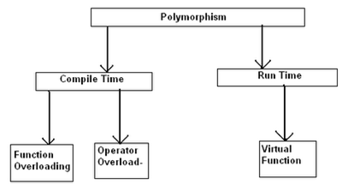

### Static or Compile Time Polymorphism

In static polymorphism, the decision is made at compile time.

* Which method is to be called is decided at compile-time only.
* Method overloading is an example of this.
* Compile time polymorphism is method overloading, where the compiler knows which overloaded method it is going to call.

Method overloading is a concept where a class can have more than one method with the same name and different parameters.

Compiler checks the type and number of parameters passed on to the method and decides which method to call at compile time and it will give an error if there are no methods that match the method signature of the method that is called at compile time.

#### Example

Hide   Shrink    Copy Code

namespace MethodOverloadingByManishAgrahari

{

class Program

{

Public class TestOverloading

{

Public void Add(string a1, string a2)

{

Console.WriteLine("Adding Two String :" + a1 + a2);

}

Public void Add(int a1, int a2)

{

Console.WriteLine("Adding Two Integer :" + a1 + a2);

}

}

Staticvoid Main(string[] args)

{

TestOverloading obj = new TestOverloading();

obj.Add("Manish " , "Agrahari");

obj.Add(5, 10);

Console.ReadLine();

}

}

}

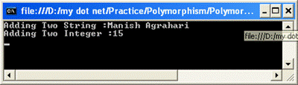

### Dynamic or Runtime Polymorphism

Run-time polymorphism is achieved by method overriding.

Method overriding allows us to have methods in the base and derived classes with the same name and the same parameters.

By runtime polymorphism, we can point to any derived class from the object of the base class at runtime that shows the ability of runtime binding.

Through the reference variable of a base class, the determination of the method to be called is based on the object being referred to by reference variable.

Compiler would not be aware whether the method is available for overriding the functionality or not. So compiler would not give any error at compile time. At runtime, it will be decided which method to call and if there is no method at runtime, it will give an error.

Hide   Shrink    Copy Code

namespace PolymorphismByManishAgrahari

{

class Program

{

Publicclass Base

{

Public virtual void Show()

{

Console.WriteLine("Show From Base Class.");

}

}

Public class Derived : Base

{

Public override void Show()

{

Console.WriteLine("Show From Derived Class.");

}

}

Staticvoid Main(string[] args)

{

Base objBase;

objBase = new Base();

objBase.Show();*// Output ----> Show From Base Class.*

objBase = new Derived();

objBase.Show();*//Output--> Show From Derived Class.*

Console.ReadLine();

}

}

}

### Virtual Keyword

According to MSDN, “The virtual keyword is used to modify a method, property, indexer or event declaration, and allow it to be overridden in a derived class.”

### Virtual Method

Virtual method is a method whose behavior can be overridden in derived class. Virtual method allows declare a method in base class that can be redefined in each derived class.

**Namespace (Refer video 18):-**

Namespace is used to organize our codes and it is collection of classes, Interface, Enum, Struct and Delegates.

●Namespaces are used to organized our program.

●They also provide assistance for avoiding name clashes.

1:-To use fully qualify name

Ex:-using System;

using System.Collections.Generic;

usingSystem.Linq;

usingSystem.Text;

usingSystem.Threading.Tasks;1111

classProgram

{

StaticvoidMain (string [] args)

{

Project.TeamA.ClassA.Print (); //Fully Qualify name

Project.TeamB.ClassA.Print (); //Fully Qualify name

}

}

namespace Project

{

NamespaceTeamA

{

ClassClassA

{

Publicstaticvoid Print()

{

Console.WriteLine ("Team a Print Method");

}

}

}

}

namespace Project

{

NamespaceTeamB

{

ClassClassA

{

Publicstaticvoid Print()

{

Console.WriteLine ("Team B Print Method");

}

}

}

}

Output:-

Team a Print Method

Team B Print Method

2:-Using Alias name

using System;

using System.Collections.Generic;

usingSystem.Linq;

usingSystem.Text;

usingSystem.Threading.Tasks;

using PTA=Project.TeamA;

using PTB=Project.TeamB;

classProgram

{

StaticvoidMain (string[] args)

{

PTA.ClassA.Print (); //PTA alias name

PTB.ClassA.Print (); //PTB alias name

}

}

namespace Project

{

NamespaceTeamA

{

ClassClassA

{

Publicstaticvoid Print()

{

Console.WriteLine("Team A Print Method");

}

}

}

}

namespace Project

{

NamespaceTeamB

{

ClassClassA

{

Publicstaticvoid Print()

{

Console.WriteLine("Team B Print Method");

}

}

}

}

Output:-

Team A Print Method

Team B Print Method

Abstraction Vs Encapsulation:-

**Abstraction** is a process where you show only “relevant” data and “hide” unnecessary details of an object from the user. Consider your mobile phone, you just need to know what buttons are to be pressed to send a message or make a call, What happens when you press a button, how your messages are sent, how your calls are connected is all abstracted away from the user.

**Encapsulation** is the process of combining data and functions into a single unit called class. In Encapsulation, the data is not accessed directly; it is accessed through the functions present inside the class. In simpler words, attributes of the class are kept private and public getter and setter methods are provided to manipulate these attributes. Thus, encapsulation makes the concept of data hiding possible.



**Static and instance class member (Refer video 20):-**

1-When a class member declared with static modifier we called that member as static member. When no static modifier declared called that instance member.

2-Static member are invoked by using class name where as instance member invoked by the object of the class.

3-An instance member belong to specific instance of a class.If I create 2 objects of a class ,I will have 2 set of instance member in the memory

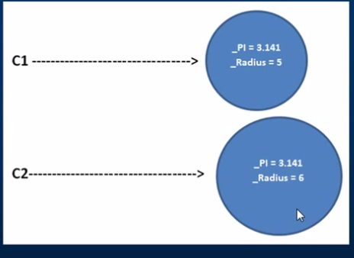

Where as there will ever be only one copy of a static member,no matter how many instances of a class are created.

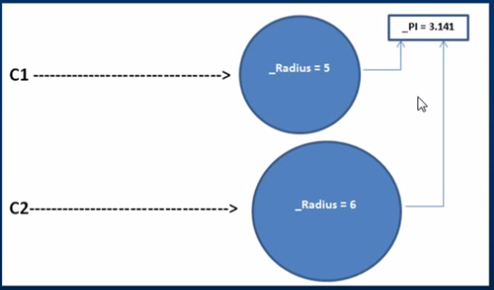

**Static Constructor:-**

1-Static constructors are used to initialize static fields in a class.

2-We can declare a static constructor by using the keyword static in front of the constructor name.

3-Static constructor is called once,no matter how many instance we create.

4-Static constructor are called before instance constructor.

5-Static constructor can not be parameterise.

6-Static constructor is called automatically we cannot call it directly.

**.Net Framework**: - It’s provides the complete environment to developer for develop, run and deploy the following application:-

1-Window Application

2-Console Application

3-Web based Application

.Net Framework is also a collection of languages likes: - Visual Basic, C# and Visual C++.

**CLR**: - It’s provides an environment in which we run our code with the feature likes: - memory management, portibility and security. The code that runs under the CLR is called Managed Code.

# Partial Classes: -A partial class splits the definition of a class over two or more source files. Each source file contains a section of the type or method definition, and all parts are combined when the application is compiled.

**There are situations when splitting a class definition is desirable:**

When working on large projects, spreading a class over separate files enables multiple programmers to work on it at the same time.

Ex:-The following MyPartialClass splits into two files, PartialClassFile1.cs and PartialClassFile2.cs:

PartialClassFile1.cs:

Public partial classMyPartialClass

{

Public MyPartialClass ()

{

}

Public void Method1 (int val)

{

Console.WriteLine (val);

}

}

PartialClassFile2.cs:

Public partial class MyPartialClass

{

Public void Method2(int val)

{

Console.WriteLine(val);

}

}

MyPartialClass in PartialClassFile1.cs defines the constructor and one public method, Method1, whereas PartialClassFile2 has only one public method, Method2. The compiler combines these two partial classes into one class as below:

Partial class:

publicclassMyPartialClass

{

public MyPartialClass()

{

}

publicvoid Method1(int val)

{

Console.WriteLine(val);

}

publicvoid Method2(int val)

{

Console.WriteLine(val);

}

}

### Partial Class Requirements:

* All the partial class definitions must be in the same assembly and namespace.
* All the parts must have the same accessibility like public or private, etc.
* If any part is declared abstract, sealed or base type then the whole class is declared of the same type.
* The Partial modifier can only appear immediately before the keywords class, struct, or interface.

Partial Methods:

A partial class or struct may contain partial methods. A partial method must be declared in one of the partial classes. A partial method may or may not have an implementation. If the partial method doesn't have an implementation in any part then the compiler will not generate that method in the final class. For example, consider the following partial method with a partial keyword:

PartialClassFile1.cs:

Public partial class MyPartialClass

{

Partial void PartialMethod (int val);

Public MyPartialClass ()

{

}

Public void Method2 (int val)

{

Console.WriteLine (val);

}

}

PartialClassFile2.cs:

Public partialclassMyPartialClass

{

Public void Method1(int val)

{

Console.WriteLine(val);

}

Partial void PartialMethod(int val)

{

Console.WriteLine(val);

}

}

PartialClassFile1.cs contains the declaration of the partial method and PartialClassFile2.cs contains the implementation of the partial method.

**When should we go for interface?**

If we don’t know complete implementation about set of services then we should go for interface

Ex:-

Interface SBIATM

{

//Set of Services

Double balance();

Int withrow();

Int miniStatement();

}

**When should we go for abstract class?**

If we know partial implementation about set of services then we go for abstract class.

Ex:-

Interface SBIATM

{

//Set of Services

Double balance()

{

Console.WriteLine (“Balance Implementation”);

}

Int withrow ();

Int miniStatement();

}

# Immutable vs. Mutable:-

**Immutable: -**stings are *immutable*. Immutable means whose state cannot be changed once it is created.

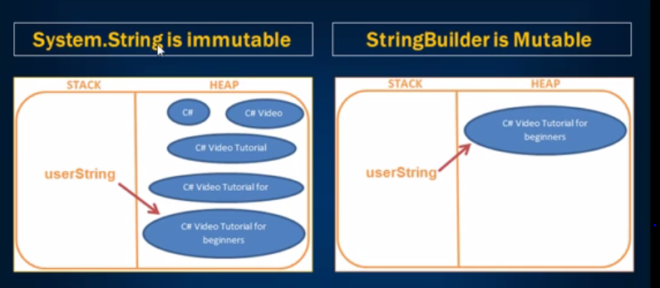

Ex:-

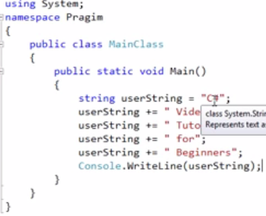

Output:-

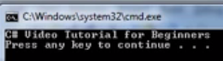

**Mutable: -**Mutable means whose state can be changed after it is created. String Builder is mutable.

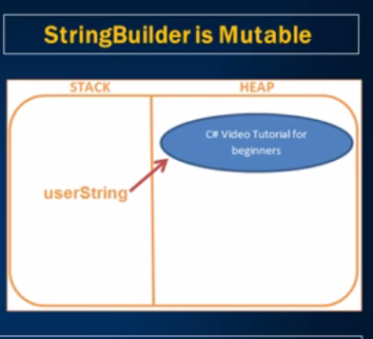

Ex:-

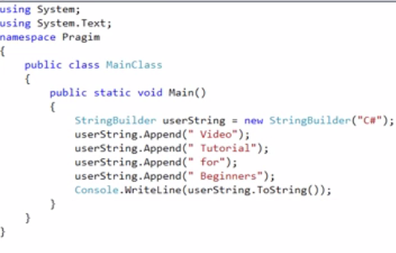

Output:-

**Delegates: -**

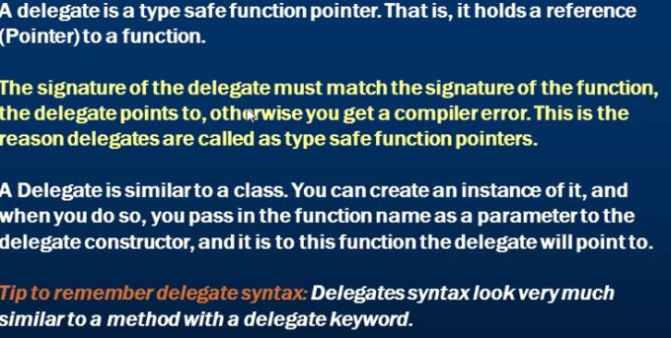

**Syntax For Create Delegate:**

pubic delegate void helloDelegate (string message);

**Create the instance of delegate:**

helloDelegate Del=new helloDelegate (Hello);//Hello is the name of method

**Call to hello method:-**

Del (“Ankit Gupta”);

**Example:-**

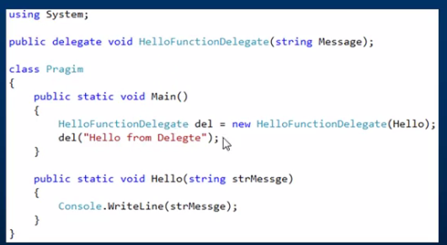

**Output:-**

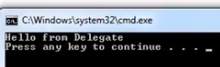

**Multicast Delegates in C#:-**

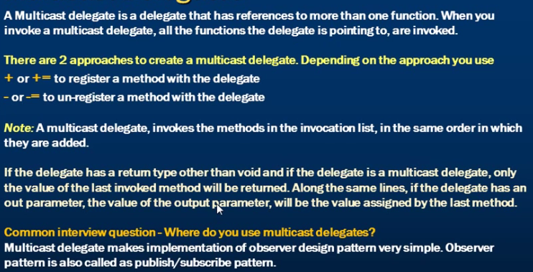

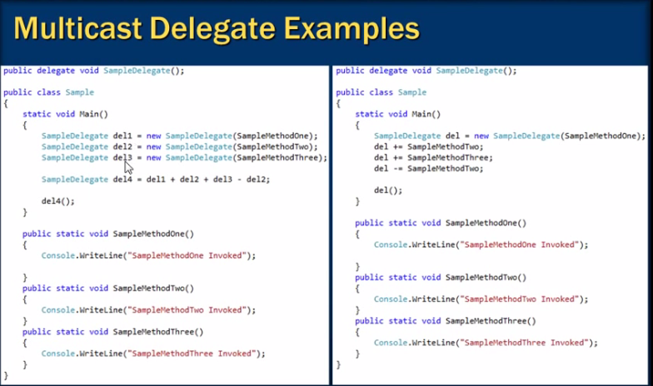

Advantage of delegates:-

1-By defining a delegate, you are saying to the user of your class, "Please feel free to assign, any method that matches this signature, to the delegate and it will be called each time my delegate is called".

2-Using delegates we can call static as well as non static method.

# Exception Handling In C#:-

Exception Handling in C# is a process to handle runtime errors. We perform exception handling so the normal flow of the application can be maintained even after runtime errors.They can be because of user, logic or system errors.

C# Exception Classes

All the exception classes in C# are derived from **System. Exception** class. Let's see the list of C# common exception classes.

|  |  |
| --- | --- |
| **Exception** | **Description** |
| System.DivideByZeroException | Handles the error generated by dividing a number with zero. |
| System.NullReferenceException | Handles the error generated by referencing the null object. |
| System.InvalidCastException | Handles the error generated by invalid typecasting. |
| System.IO.IOException | Handles the Input Output errors. |
| System.FieldAccessException | Handles the error generated by invalid private or protected field access. |

**Application Exception and System Exception:-**

Systems Exception is handled by the CLR like-Arithmetic exception, IndexOutofBound exception, NullReference Exception where as Application exception is handled by the programmer according to the program need. Like a number should not be divide by the odd number.

C# Exception Handling Keywords:-

In C#, we use 4 keywords to perform exception handling:

* try
* catch
* finally, and
* throw

# C# try/catch

In C# programming, exception handling is performed by try/catch statement. The **try block** in C# is used to place the code that may throw exception. The **catch block** is used to handle the exception. The catch block must be preceded by try block.

But in C#, both catch and finally blocks are optional. The try block can exist either with one or more catch blocks or a finally block or with both catch and finally blocks.

Exceptions are nothing but objects of the type Exception. The Exception is the ultimate base class for any exceptions in C#. The C# itself provides a couple of standard exceptions. Or even the user can create their own exception classes, provided that this should inherit from either the Exception class or one of the standard derived classes of the Exception class like DivideByZeroExcpetion or ArgumentException and so on.

### C# example without try/catch

1. **using** System;
2. **public** **class** ExExample
3. {
4. **public** **static** **void** Main(**string**[] args)
5. {
6. **int** a = 10;
7. **int** b = 0;
8. **int** x = a/b;
9. Console.WriteLine("Rest of the code");
10. }
11. }

Output:

Unhandled Exception: System.DivideByZeroException: Attempted to divide by zero.

### C# try/catch example

1. **using** System;
2. **public** **class** ExExample
3. {
4. **public** **static** **void** Main(**string**[] args)
5. {
6. **try**
7. {
8. **int** a = 10;
9. **int** b = 0;
10. **int** x = a / b;
11. }
12. **catch** (Exception e) { Console.WriteLine(e); }
14. Console.WriteLine("Rest of the code");
15. }
16. }

Output:

System.DivideByZeroException: Attempted to divide by zero.

Rest of the code

# C# finally

C# finally block is used to execute important code which is to be executed whether exception is handled or not. It must be preceded by catch or try block.

### C# finally example if exception is handled

1. **using** System;
2. **public** **class** ExExample
3. {`
4. **public** **static** **void** Main(**string**[] args)
5. {
6. **try**
7. {
8. **int** a = 10;
9. **int** b = 0;
10. **int** x = a / b;
11. }
12. **catch** (Exception e) { Console.WriteLine(e); }
13. **finally** { Console.WriteLine("Finally block is executed"); }
14. Console.WriteLine("Rest of the code");
15. }
16. }

Output:

System.DivideByZeroException: Attempted to divide by zero.

Finally block is executed

Rest of the code

**Multiple Catch Blocks:-**

A try block can throw multiple exceptions that can be handled by multiple catch blocks. Remember that catch block should we implement in hierarchal manner means child to parents class.

using System;

class MyClient

{

public static void Main()

{

int x = 0;

int div = 0;

try

{

div = 100/x;

Console.WriteLine ("Not executed line");

}

catch (DivideByZeroException de)

{

Console.WriteLine ("DivideByZeroException”);

}

catch (Exception ee)

{

Console.WriteLine ("Exception”);

}

finally

{

Console.WriteLine ("Finally Block");

}

Console.WriteLine ("Result is {0}",div);

}

}

# C# - throw keyword:

An exception can be raised manually by using the throw keyword. Any type of exceptions which is derived from *Exception* class can be raised using the throw keyword.

Example: throw an exception

Static void Main (string [] args)

{

Student std = null;

try

{

PrintStudentName (std);

}

catch (Exception ex)

{

Console.WriteLine (ex.Message);

}

Console.ReadKey ();

}

Private static void PrintStudentName (Student std)

{

if (std == null)

throw new NullReferenceException ("Student object is null.");

Console.WriteLine (std.StudentName);

}

[Try it](http://www.tutorialsteacher.com/codeeditor?cid=cs-ZMcyCm)

Output:

Student object is null.

In the above example, PrintStudentName () method raises NullReferenceException if Student object is null.

Please notice that throw creates an object of any valid exception type using the new keyword. The throw keyword cannot be used with any other type which does not derive from the Exception class.

**Application Exception:-**

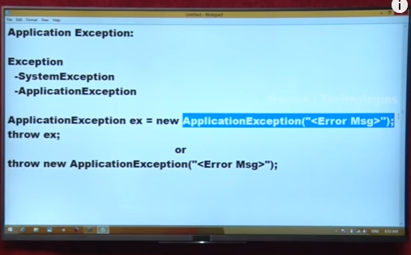

**Example:-**

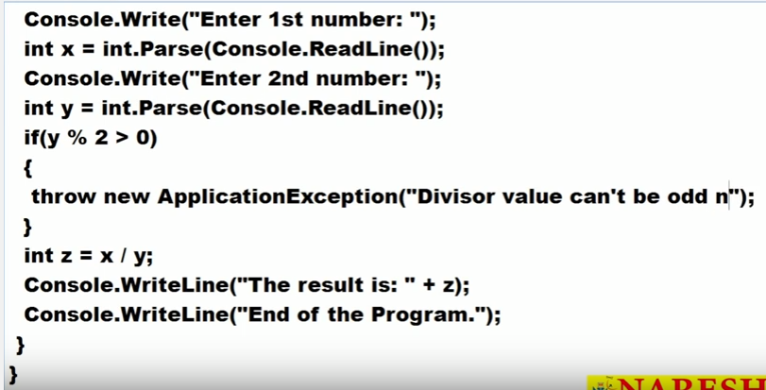

**Output:-**

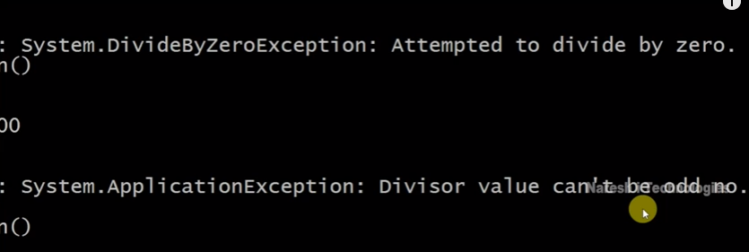

**Defining Own Exception Class:-**

For defining own exception class first we should have to inherit our exception class from one of the predefine exception class like:-Exception,ArithmeticException and ApplicationException class. It’s recommended to inherit our exception class from Exception class.

**Example of Custom Exception:-**

In below example we used the ApplicationException Class

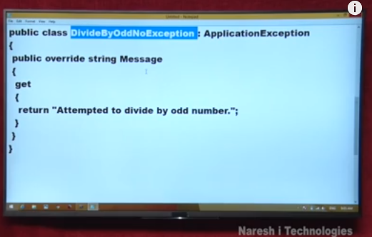

**Note: -**Message is define as a virtual and read only property in Exception Class that why we override the Message property in our exception class.

Copy the above code and paste in our previous program

1-

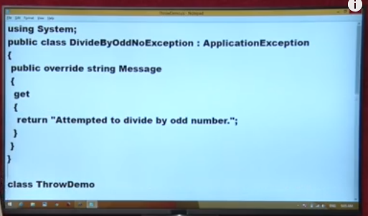

2

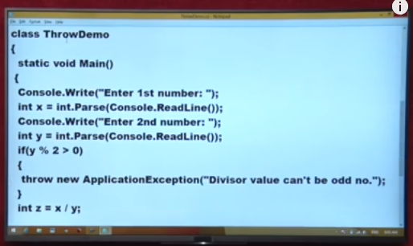

Comment the throw new ApplicationException(“”); as below

3

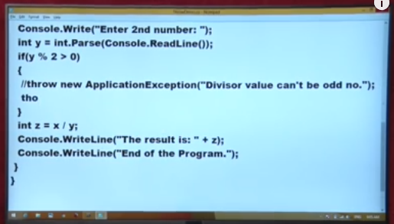

4

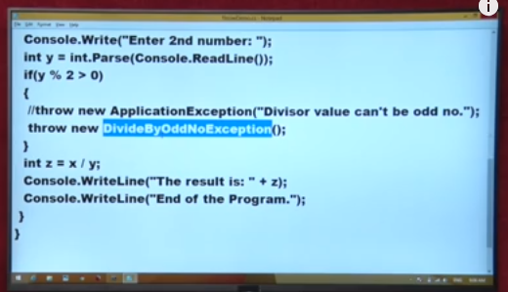

**Output:-**

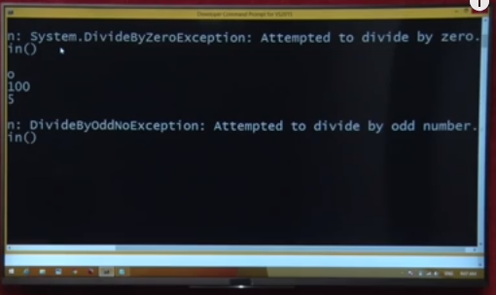

# Properties in C# Programming: - (Refer to Naresh IT Video)

A property is a member that provides a flexible mechanism to read, write, or compute the value of a private field. Properties can be used as if they are public data members, but they are actually special methods called accessors. This enables data to be accessed easily and still helps promote the safety and flexibility of methods.

**Problem if we declared a field as a public:-**

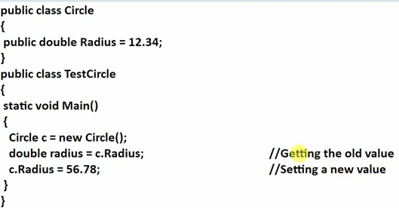

**-**if we declared a field as a public in a class then we can easily access that field outside the class.

-Also we can get the value as well as modify that value so security problem is there. Means anyone can get that value and set that value also.

**If we declared the field as a private:-**

-If we declared a field as a private so we can get and set the value using the method and property only. Means using get () we can get the value and using set () we can modify that value of the field.

-So here security problem is not there because if we use only get () so we can only get the value but modification is not possible.

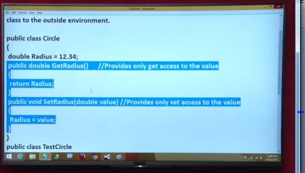

Circle (First Class)

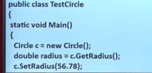

TestCircle (Second Class)

-So method is provide get access, set access or get set both accesses. But public field provide set get both only set and only get is not possible using public field.

**Properties in C#:-**

We can use the property in place of the method. We have two advantages of using properties as below-

-Advantage of property is using a single block we can do the set as well as get both of the operation. No need to declare get method and set method separately.

-In property we did not need to pass parameter but in case of method we need to pass the parameter in set method.

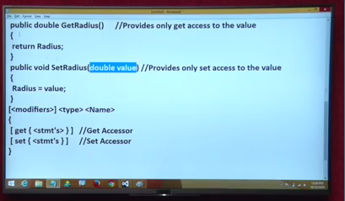

Using property in place of method

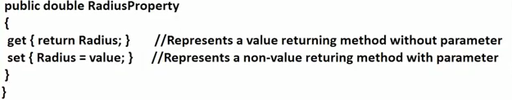

How to perform get and set operation on the property

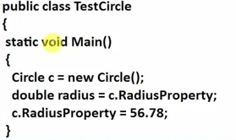

**-**Using property we can also define some condition for getting and setting the value of the private field.

For Example the radius value cannot be less than old radius value like below example:-

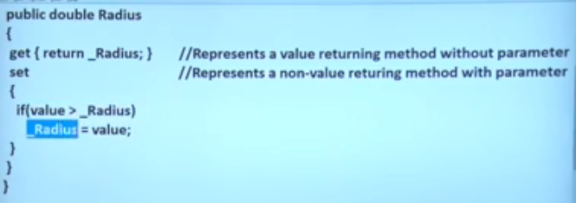

**Note: -**If we use the public field then we cannot perform any condition so for condition we need to use the property.

**Collection in C#.Net:-**

A collection is a dynamic array before going to collection first we understand what the problem in array is.

1-Array is fixed length once we declared we cannot change the size of the array.If we try to change the size then it create one new array and copy all the data from old array to new array. We have a two option to create new array.

-First to create the new array as manually and copy the old arraydata to new array data.

-Second using the Array.Resize () of system class as below.

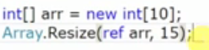

Array.Resize () method create new and copy the data from old array to new array and then destroyed the old array.

2- We cannot insert the value into the middle of the array. If we tried to insert the value middle of the array then the size of array is increase that is not possible.

3- We cannot delete the value from the middle of the array.

So using collection above problem will not occur. We can increase the size of the collection as well as we can also insert and delete the value middle of the collection.

**Types of Collection:-**

**1-Non-Generic Collection:-**

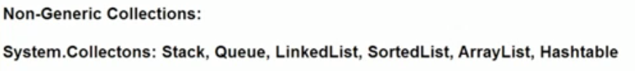

**-** All the non-generic collection definesas classes in the System. Collections namespace.

**Difference b/w Array and ArrayList:-**

1-Array is fixed length where as ArrayList is variable length means ArrayList list increase automatically but Array size we cannot increase.

2-We cannot insert the value into the middle of the Array but in case of ArrayList we can insert the value middle of ArrayList.

3-We cannot delete the value into the middle of the Array but in case of ArrayList we can delete the value middle of ArrayList.

**Example of ArrayList:-**

using System;

using System.Collections.Generic;

using System.Linq;

using System.Text;

using System.Threading.Tasks;

using System. Collections;

namespace ConsoleApplication1

{

classProgram

{

staticvoid Main (string [] args)

{

ArrayList al = newArrayList ();

Console.WriteLine (al.Capacity);

al.Add (10);

Console.WriteLine (al.Capacity);

al.Add (20); al.Add (30); al.Add (40); al.Add (50);

Console.WriteLine (al.Capacity);

foreach (object obj in al)

Console. Write (obj + " ");

Console.WriteLine ();

al.Insert (2, 25); //Insert Middle Of The Element

foreach (object obj in al)

Console. Write (obj + " ");

Console.WriteLine ();

al.Remove (40); //Removing Middle Of The Element

foreach (object obj in al)

Console. Write (obj + " ");

Console.ReadLine ();

}

}

}

**Output:-**

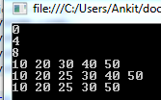

**Array and ArrayList**: - Stored the data as a key/value combination.

**Problem with ArrayList:-**

Suppose we want to store the below data in the ArrayList.



In the above ArrayList we are not able to find that in which location (index) email-id saves. Currently there are only 13 fields if the field is more than 13 like 100 or more than it is problem to find any particular location of the field.

So to overcome the above problem we used the HashTable.

**HashTable:-**

-HashTable is just like an ArrayList also capable to auto resize.

-It also stored the data as Key/Value pair but in case of HashTable key is user defined.



**Example:-**

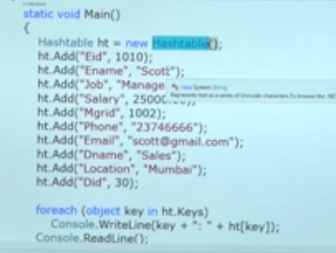

**Output:-**



**Note:-** Fetching the data from the HashTable is very faster than ArrayList.

**Drawback of collection:-**

1-Collections are not type safe means we can store any type of value in a collection.

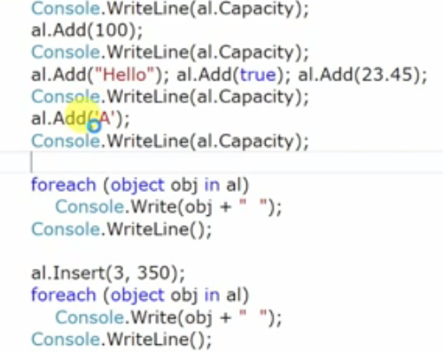

Output:-



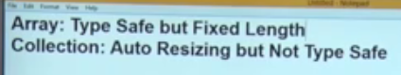

2-Collection can take any type of value as a parameter as compare that without generating any error (parameter just for example.

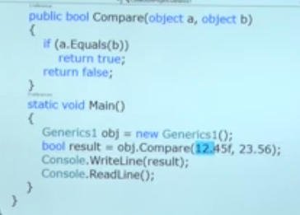

-It compares 12.45f, 23.56 without given any error.

3-Boxing and un-boxing process is perform which will take un-necessary time.

So to overcome the above problem in 2.0 Microsoft introduces generic collection.

**Advantage of Generic Collection:-**

Ex:-

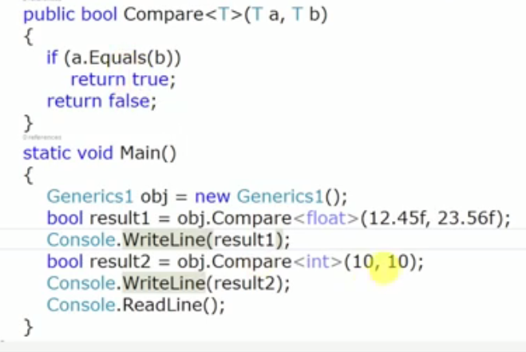

Output:-



1-According to the above example the type of the value is automatically change means the method is changing to itself according to the type of value we passed.

2- Boxing and un-boxing process is not performs.

**Generic Collection:-**

Generic collection is type safe and auto resizing. Like

List<T>

<T> -> Represent type of value we want to store in List.

List<int> li=new List<int> ();

List<String> ls=new List<String> ();

-Type can be a single or complex type also like below example.

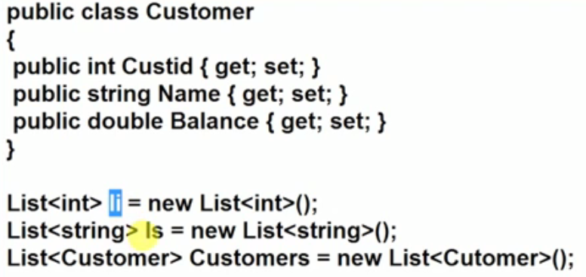

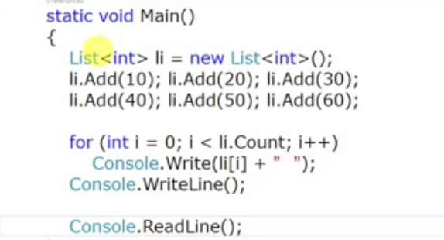

Note: - In above example if we try to insert the string and double value then it’s showing error because that list is integer type.

Note: -Add () method of non-generic collection is takean object type value as a parameter that is the reason collection is not type safe.

-Add () method of generic collection is take a type value as we define.

Ex: - List<int> obj=new List<int>(); // Add () take the int type value only for that list.

**Dictionary Class (Same as HashTable in Collections):-**

Dictionary is just like a HashTable in collection. It also stored the value as a combination of key/value. Key is user defined.

Ex:-

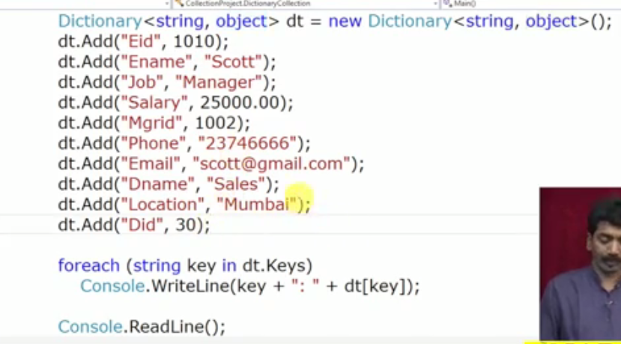

**Output:-**



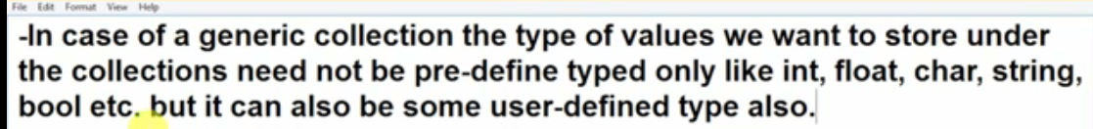

**Multithreading in C#:-**

**Multitasking: -**Means running the more than one application at a time like our window operating system we can run the notepad, VLC , MS Office, play the game at the same time that is called multitasking.

**Thread: -**It is a lightweight process means thread is the unit which execute the code under the application. Every application by default has a thread that executes the logic of the application that is called main thread.





Ex:-

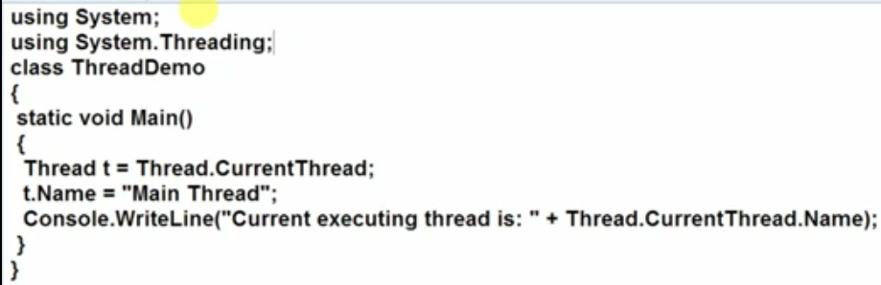

Output:-



**Drawback of Single Thread Model:-**

-In single model thread only one thread is there so if in our program 3 method is there then that tread execute all the three method one by one. So the performance issue is there.

-Suppose the second method is fetching some data from the database but database is busy thread is wait until the database is free when database is free it fetch the data from the database and then execute the 3 method.

Ex:-

using System;

using System.Collections.Generic;

using System.Linq;

using System.Text;

using System.Threading;

using System.Collections;

namespace ConsoleApplication1

{

classProgram

{

publicstaticvoid Test1()

{

for (int i=1; i<=10; i++)

{

Console.WriteLine("Test1:"+i);

}

}

publicstaticvoidTest2 ()

{

for (int i = 1; i <= 10; i++)

{

Console.WriteLine ("Test2:"+i);

}

}

publicstaticvoidTest3 ()

{

for (int i = 1; i <= 10; i++)

{

Console.WriteLine ("Test3:"+i);

}

}

staticvoidMain (string [] args)

{

Test1 ();

Test2 ();

Test3 ();

}

}

}

Output:-

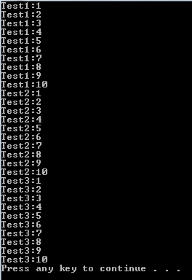

**Solutions:-**

-So using the multithreading we can solve the above problem means for 3 method we use 3 separate threads.

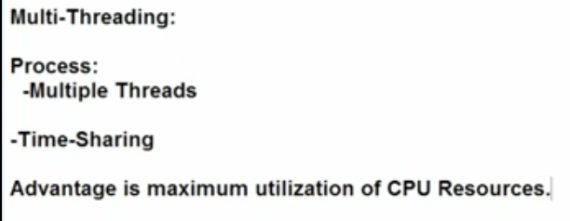

Example:-

using System;

using System.Collections.Generic;

using System.Linq;

using System.Text;

using System.Threading;

using System.Collections;

namespace ConsoleApplication1

{

classProgram

{

publicstaticvoidTest1 ()

{

for (int i=1; i<=10; i++)

{

Console.WriteLine ("Test1:"+i);

}

}

publicstaticvoid Test2()

{

for (int i = 1; i <= 10; i++)

{

Console.WriteLine("Test2:"+i);

}

}

publicstaticvoid Test3()

{

for (int i = 1; i <= 10; i++)

{

Console.WriteLine("Test3:"+i);

}

}

staticvoid Main(string [] args)

{

Thread t1=newThread (Test1);

Thread t2=newThread(Test2);

Thread t3 = newThread(Test3);

t1.Start();

t2.Start();

t3.Start();

}

}

}

-The output of the above program is change every time when we run the program. Because the CPU is sharing the equal time between all of its thread.

-In the above program we have total 4 thread 1 main thread and 3 child threads.

Output:-

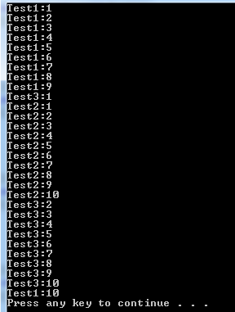

Ex:-

using System;

using System.Collections.Generic;

using System.Linq;

using System.Text;

using System.Threading;

using System.Collections;

namespace ConsoleApplication1

{

classProgram

{

publicstaticvoid Test1()

{

For(int i=1; i<=10; i++)

{

Console.WriteLine("Test1:"+i);

}

}

publicstaticvoid Test2()

{

for (int i = 1; i <= 10; i++)

{

Console.WriteLine ("Test2:"+i);

if (i == 3)

{

Console.WriteLine ("Thread 2 is sleep");

Thread.Sleep (5000);

Console.WriteLine ("Thread 2 woke up");

}

}

}

publicstaticvoidTest3 ()

{

for (int i = 1; i <= 10; i++)

{

Console.WriteLine ("Test3:"+i);

}

}

staticvoid Main(string [] args)

{

Thread t1=newThread (Test1);

Thread t2=newThread (Test2);

Thread t3 = newThread (Test3);

t1.Start ();

t2.Start ();

t3.Start ();

}

}

}

-In the above example we use the sleep () method for sleep the thread 2 for 5 sec but in the same time thread1 and thread 2 continue his execution and after 5 sec thread 2 is woke up and again complete his execution.

Output:-

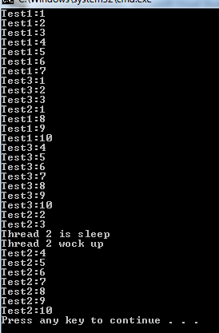

**Constructor in Thread Class:-**

**ThreadStart Delegates:-**

ThreadStart is a delegate that is used to bind the method with the ThreadStart delegates.

Ex: - ThreadStart obj = newThreadStart (Test1); //ThreadStart is delegates

-If we did not use the ThreadStart delegate then CLR or .Net framework implicitly create the instance of the delegates and bind the method with delegates object.

Ex: - Thread t1=newThread (Test);

-So we can use any of the below both are same.

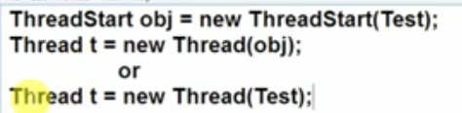

Example:-

using System;

using System.Collections.Generic;

using System.Linq;

using System.Text;

using System.Threading;

using System.Collections;

namespace ConsoleApplication1

{

classProgram

{

publicstaticvoid Test1()

{

for(int i=1; i<=10; i++)

{

Console.WriteLine("Test1:"+i);

}

}

staticvoid Main(string[] args)

{

ThreadStart obj = newThreadStart(Test1); //ThreadStart is delegates

Thread t1=newThread(obj);

t1.Start();

}

}

}

**Output:-**

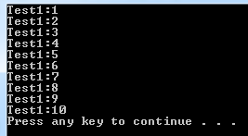

**Extension Method in C#:-**

**What are extension methods?**  
  
Extension methods are use to add methods to existing types without creating a new derived type, recompiling, or otherwise modifying the original type.   
  
An extension method is a special kind of static method, but they are called as if they were instance methods on the extended type.

**How to use extension methods?**  
  
An extension method is a static method of a static class, where the "this" modifier is applied to the first parameter. The type of the first parameter will be the type that is extended.  
Extension methods are only in scope when you explicitly import the namespace into your source code with a using directive.

**Program to show how to use extension methods**  
Create a project Class Library as:  
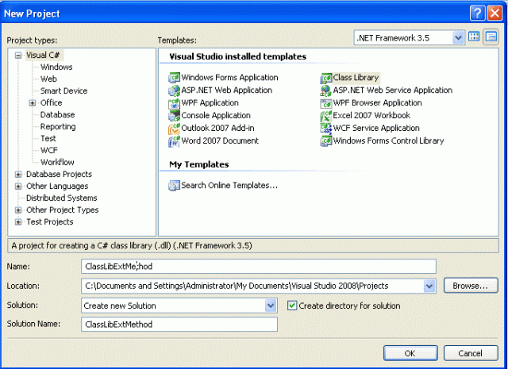  
  
using System;  
using System.Text;  
  
namespace ClassLibExtMethod  
{  
    public class Class1  
    {  
        public string Display()  
        {  
            return ("I m in Display");  
        }  
  
        public string Print()  
        {  
            return ("I m in Print");  
        }  
    }  
}  
  
Now create a new project using "File" -> "New" -> "Project...".  
  
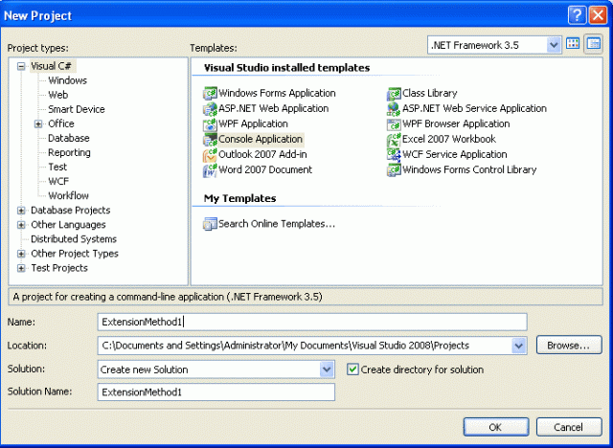  
  
Add the reference of the previously created class library to this project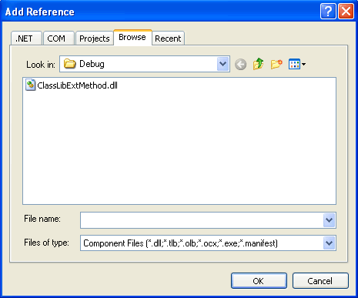  
**Use the following code and use the ClassLibExtMEthod.dll in your namespace:**  
using System;  
using System.Text;  
using ClassLibExtMethod;  
  
namespace ExtensionMethod1  
{  
    public static class XX  
    {  
         public static void NewMethod(this Class1 ob)  
        {  
            Console.WriteLine("Hello I m extended method");  
        }  
    }  
  
    class Program  
    {  
        static void Main(string[] args)  
        {  
            Class1 ob = new Class1();  
            ob.Display();  
            ob.Print();  
            ob.NewMethod();  
            Console.ReadKey();  
        }  
    }  
}  
  
You can see the extension method with an arrow (different from the normal method sign), since they were instance methods on the extended type. See the figure below:  
  
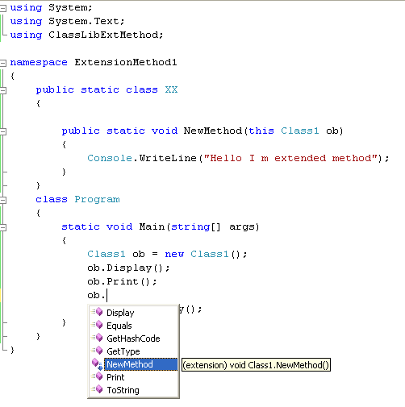  
**Output of the preceding program**  
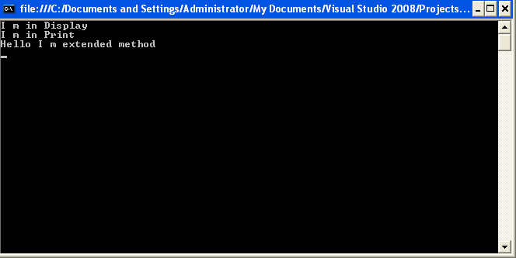

**Benefits of extension methods**

* Extension methods allow existing classes to be extended without relying on inheritance or having to change the class's source code.
* If the class is sealed than there in no concept of extending its functionality. For this a new concept is introduced, in other words extension methods.

**Interface Example:-**

Public interface Interface1

{

void MyInterfaceFunction();

}

Public interface Interface2

{

void MyInterfaceFunction();

}

publicclass MyTestBaseClass:Interface1,Interface2

{

void Interface1.MyInterfaceFunction()

{

MessageBox.Show("Frm MyInterface1 Function()");

return;

}

void Interface2.MyInterfaceFunction()

{

MessageBox.Show("Frm MyInterface2 Function()");

return;

}

}

MyTestBaseClass obj = new MyTestBaseClass();

((Interface1)obj).MyInterfaceFunction();

((Interface2)obj).MyInterfaceFunction();

**Static Class in C#:-**

-A [static](https://docs.microsoft.com/en-us/dotnet/csharp/language-reference/keywords/static) class is basically the same as a non-static class, but there is one difference: a static class cannot be instantiated so all the member is accessible with the class name.

-Static class is declared with the static keyword.**Static classes** are sealed and therefore cannot be **inherited**.

-static class must contain only static members

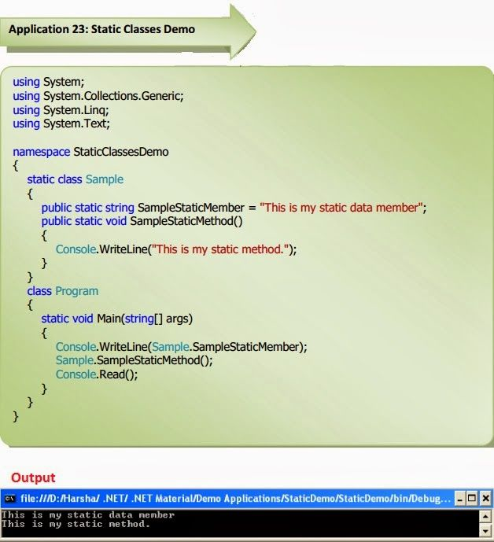

**Why to use static Class**

Static class is use to define the member and function globally. So we can access that member and function anywhere without creating the object of the static class.

# Value vs Reference Types in C#:-

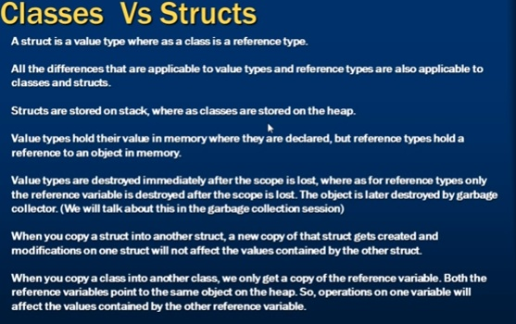

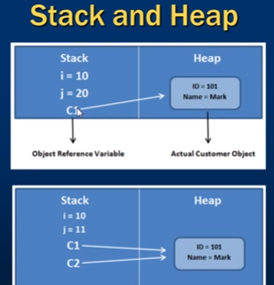



**Design Pattern in C#.Net:-**

Design patterns are solutions to software design problems you find again and again in real-world application development. Patterns are about reusable designs and interactions of objects.

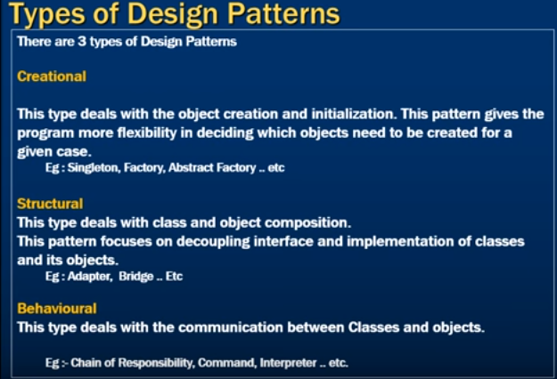

How to insert null into integer value:-

int? a=null;

**Clone and Copy :-**

Clone will copy the structure of a data where as Copy will copy the complete structure as well as data.

**Copy:-**

Consider this string[] example:

String[] arr1 = new string[] { "one", "two", "three","four" };

string[] arr2 = arr1; //copy

Here declare two string array arr1 and arr2 and then copy arr1 to arr2.

The arr2 now contains the same values, but more importantly the array object itself points to the same object reference as the arr1 array.

Here now assign the value to arr2

arr2[1] = "zero";

Now display the values in message box, What would be the output for the following statements?

MessageBox.Show(arr1[1].ToString() + "    " + arr2[1].ToString());

Considering both arrays point to the same reference we would get:

zero            zero

Form the next sample code you can understand how clone() is working

String[] arr3 = new string[] { "one", "two", "three", "four" };

string[] arr4 = (string[])arr3.Clone(); //clone

The arr4 now contains the same values, but in this case the array object itself points a different reference than the arr3.

arr4[1] = "zero";

What would be the output now for the following statements?

MessageBox.Show(arr3[1].ToString() + "    " + arr4[1].ToString());

two            zero

**finalize-dispose:-**

Finalize() is called by the Garbage Collector for deallocate the memory for the unreferenced object. The Garbage Collector calls this method at some point after there are no longer valid references to that object in memory.

The framework does not guarantee that when this will happen, you can force for Garbage Collection but it will hurt performance of your program. Finalize() belongs to the Object class and it will be called by the runtime.

Dispose()

There are some resources like windows handles, database connections , network connections, files, etc. which cannot be collected by the Garbage Collector. If you want to explicitly release some specific objects then this is the best to implement IDisposable and override the Dispose () method of IDisposable interface.

The Dispose () method is not called automatically and you must explicitly call it from a client application when an object is no longer needed. Dispose() can be called even if other references to the object are alive.

using Microsoft.Win32.SafeHandles;

using System;

using System.Runtime.InteropServices;

class BaseClass : IDisposable

{

// Flag: Has Dispose already been called?

bool disposed = false;

// Instantiate a SafeHandle instance.

SafeHandle handle = new SafeFileHandle(IntPtr.Zero, true);

// Public implementation of Dispose pattern callable by consumers.

public void Dispose()

{

Dispose(true);

GC.SuppressFinalize(this);

}

// Protected implementation of Dispose pattern.

protected virtual void Dispose(bool disposing)

{

if (disposed)

return;

if (disposing) {

handle.Dispose();

// Free any other managed objects here.

//

}

disposed = true;

}

}

**Difference between var and dynamic keyword:-**

1. When were they introduced

•var was introduced in C# 3.0

•dynamic was introduced in C# 4.0

2. Type inference of variables

•var is a statically typed variable. It results in a strongly typed variable, in other words the data type of these variables are inferred at compile time. This is done based on the type of value that these variables are initialized with.

•dynamic are dynamically typed variables. This means, their type is inferred at run-time and not the compile time in contrast to var type.

3. Initialization of variables

•var type of variables are required to be initialized at the time of declaration or else they encounter the compile time error: Implicitly-typed local variables must be initialized.

•dynamic type variables need not be initialized when declared.

Ex:-

dynamic di =20;

dynamic ds ="sadlfk";

var vi =10;

var vsTemp="sdklf";

Console.WriteLine (di.GetType ().ToString ());//Prints System.Int32

Console.WriteLine (ds.GetType ().ToString ());//Prints System.String

Console.WriteLine (vi.GetType ().ToString ());//Prints System.Int32

Console.WriteLine (vsTemp.GetType ().ToString ());//Prints System.String

**ds =12;**//ds is treated as string until this stmt now assigning integer.

Console.WriteLine (ds.GetType ().ToString());**//Prints System.Int32**

**vs =12**;//*Gives compile time error* - Here is the difference between Var and Dynamic. var is compile time bound variable.

**Difference between Hashtable and Dictionary:-**

1**-**Dictionary is generic type; hash table is not a generic type.

2-The Hashtable is a weakly typed data structure, so you can add keys and values of any Object Type to the Hashtable. The Dictionary class is a strongly types < T Key, T Value > and you must specify the data types for both the key and value.

Ex: -Hashtable numbers = new Hashtable ();

Dictionary<int, string> dictionary = new Dictionary<int, string > ();

3-While perform operations Dictionary is faster because there is no boxing/unboxing while in Hashtable boxing/unboxing will happened and which may have memory consumption as well as performance penalties.

4-When we add the multiple entries in Dictionary, the order in which the entries are added is maintained. When we retrieve the items from Dictionary we will get the records in the same order we have inserted them. Whereas we add same records in Hashtable the order is not maintained.

5-When we try to get the value of key which does not exists in the collection, the  dictionary throws an exception of 'KeyNotFoundException' while hashtable return null value.

Why .Net supports Multiple Language:-

In .NET, code is compiled to Microsoft Intermediate Language (MSIL for short). This is called as Managed Code. This Managed code is run in .NET environment. So after compilation to this IL the language is not a barrier. A code can call or use a function written in another language the only thing is a language should comply with the Common Language Runtime standard to become a .NET language.

**How CTS converts the data type to a common data type:-**

To implement or see how CTS is converting the data type to a common data type, for example, when we declare an int type data type in C# and VB.Net then they are converted to int32. In other words, now both will have a common data type that provides flexible communication between these two languages.  
  
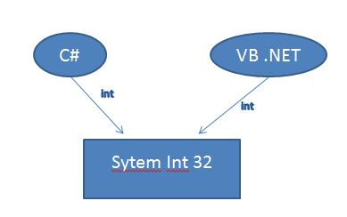  
  
Let's take a live example using a Double data type and we will see how .NET helps to make the data types of C# and VB.NET common to each other for easy communication.

CLS

CLS stands for Common Language Specification and it is a subset of CTS. It defines a set of rules and restrictions that every language must follow which runs under .NET framework. The languages which follows these set of rules are said to be CLS Compliant. In simple words, CLS enables cross-language integration.

**For example**, one rule is that you cannot use multiple inheritance within .NET Framework. As you know C++ supports multiple inheritance but; when you will try to use that C++ code within C#, it is not possible because C# doesn’t supports multiple inheritance.

One another rule is that you cannot have members with same name with case difference only i.e. you cannot have add() and Add() methods. This easily works in C# because it is case-sensitive but when you will try to use that C# code in VB.NET, it is not possible because VB.NET is not case-sensitive.

**difference between bug defect and error:-**

**Error:** It the one which is generated because of wrong login, loop or due to syntax. Error means normally arises in software Error means to change the functionality of the program.

**Bug:**  
An Error found in the development environment before the product is shipped to the customer.

Bug: Simply Bug is an error found BEFORE the application goes into production. A programming error that causes a program to work poorly, produce incorrect results, or crash.  An error in software or hardware that causes a program to malfunction.

**Defect:**  
[Defect](http://softwaretesting-guideline.blogspot.in/p/defect-reporting.html) is the difference between expected and actual result in the context of testing. Defect is the deviation of the customer requirement. An Error found in the product itself after it is shipped to the customer. Defect is an error found AFTER the application goes into production. Simply defect can be defined as a variance between expected and actual. Defect is an error found AFTER the application goes into production.  
  
**Categories of defects** - There are three main category of defects;  
**Wrong:**The requirements have been implement the wrong way. This defect is a variance from the given specification.  
  
**Missing:**There was a requirement given by the client and it was not done. This is a variance from the specifications, an indication that a specification was not implemented, or a requirement of the customer was not noted correctly.

**Extra:**A requirement incorporated into the product that was not given by the end   customer. This is always a variance from the specification, but may be an attribute  desired by the user of the product. However, it is considered a defect because it’s  a variance from the existing requirements.

# Difference between int.Parse,Convert.ToInt32 and int.TryParse

### int.Parse(string s)

Simply, int.Parse (string s) method converts the string to integer. If string s is null, then it will throw **ArgumentNullException**. If string s is other than integer value, then it will throw **FormatException**. If string s represents out of integer ranges, then it will throw **OverflowException**.

### Convert.ToInt32(string s)

Simply, Convert.ToInt32(string s) method converts the string to integer. If string s is null, then it will return **0** rather than throw **ArgumentNullException**. If string s is other than integer value, then it will throw **FormatException**. If string s represents out of integer ranges, then it will throw **OverflowException**.

### int.TryParse(string s,Out)

Simply int.TryParse(string s,out int) method converts the string to integer out variable and returns true if successfully parsed, otherwise false. If string s is null, then the out variable has 0 rather than throw **ArgumentNullException**. If string s is other than integer value, then the out variable will have 0rather than **FormatException**. If string s represents out of integer ranges, then the out variable will have 0rather than throw **OverflowException**.

# Boxing and Unboxing:-

# Boxing is the process of converting a [value type](https://docs.microsoft.com/en-us/dotnet/csharp/language-reference/keywords/value-types) to the type object or to any interface type implemented by this value type. When the CLR boxes a value type, it wraps the value inside a System.Object and stores it on the managed heap. Unboxing extracts the value type from the object. Boxing is implicit; unboxing is explicit.

In the following example, the integer variable i is *boxed* and assigned to object o.

C#Copy

int i = 123;

// The following line boxes i.

object o = i;

The object o can then be unboxed and assigned to integer variable i:

C#Copy

o = 123;

i = (int)o; // unboxing

**calling GC.Collect() will clean up any objects that are no longer referred.**

# [difference between static and sealed class in .NET:-](https://www.codeproject.com/Questions/256532/difference-between-static-and-sealed-class-in-NET)

Sealed classes:

1)Can create instances, but cannot inherit

2)Can contain staticas well as nonstatic members.

Static classes:

1)Can neither create their instances, nor inherit them

2)Can have static members only.

1)Both static and sealed can't be inherited.

2). we can't create object of static class where as we can create object of sealed class.  
3). we can not use sealed class as a base class where as static can be use as a base class.

# IEnumerable vs IQueryable in LINQ:-

IEnumerable and IQueryable are used for data manipulation in LINQ from the database and collections.

**Differences**  
  
**IEnumerable**

1. IEnumerable exists in the System.Collections namespace.  
     
   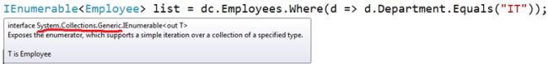
2. IEnumerable is suitable for querying data from in-memory collections like List, Array and so on.
3. While querying data from the database, IEnumerable executes "select query" on the server-side, loads data in-memory on the client-side and then filters the data.   
     
   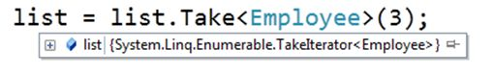
4. IEnumerable is beneficial for LINQ to Object and LINQ to XML queries.

**IQueryable**

1. IQueryable exists in the System.Linq Namespace.  
     
   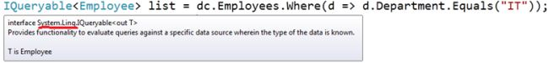
2. IQueryable is suitable for querying data from out-memory (like remote database, service) collections.
3. While querying data from a database, IQueryable executes a "select query" on server-side with all filters.  
     
   
4. IQueryable is beneficial for LINQ to SQL queries.

What is the use of using statement in C#

The using statement is used clean up the object.The using statement obtains the resource specified, executes the statements and finally calls the Dispose method of the object to clean up the object.

Dispose the object using (SqlConnection oConnection=new SqlConnection()) { oConnection.Open(); } if you won't close the connection it will close the connection automatically once SqlConnection has been executed completing.

using (TextWriter w = File.CreateText("log.txt"))

{

w.WriteLine("This is line one");

}

**Constructor in C#:-**

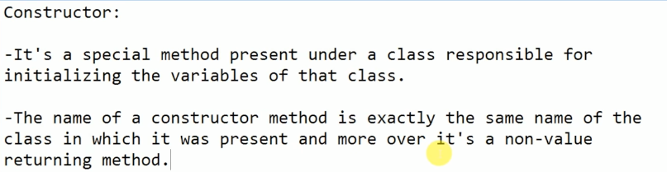

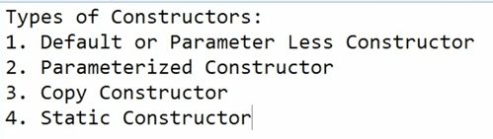

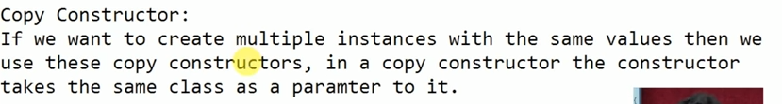

**Example:-**

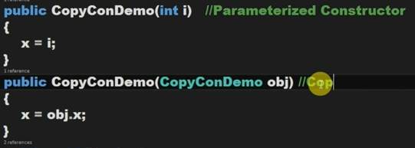

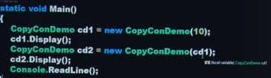

**Static Constructor:-**

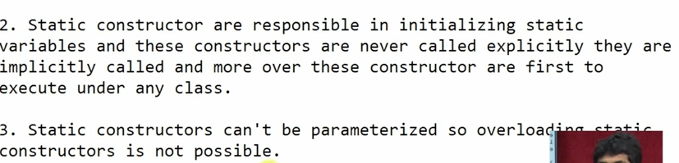

### What are Explicit and Implicit Interfaces?

There are two ways of implementing C# interfaces “Explicit” and “Implicit”.

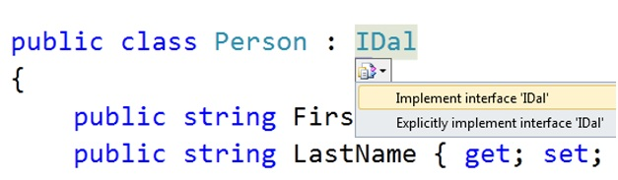

When you implicitly implement an interface below is how the code looks like. “IDal” is the interface and “Add” and “Update” are the methods implemented implicitly. Most of the developers implement interface implicitly.

Hide   Copy Code

public class Person : IDal

{

public string FirstName { get; set; }

public string LastName { get; set; }

public void Add()

{

throw new NotImplementedException();

}

public void Update()

{

throw new NotImplementedException();

}

}

If you explicitly implement an interface below is how the code looks like. **The difference is that the “Add” and “Update” methods are now private**.

Hide   Copy Code

public class Person : IDal

{

public string FirstName { get; set; }

public string LastName { get; set; }

void IDal.Add()

{

throw new NotImplementedException();

}

void IDal.Update()

{

throw new NotImplementedException();

}

}

In simple words the difference between “Implicit” interface and “Explicit” interface is that in implicit the interface methods are publicly implemented while in explicit the methods are privately implemented.

So the next question which arises is why do we have this difference of public VS private and when should we use “Implicit” interface VS “Explicit” interface.

# Optional Parameter In C#

In general meaning, Optional stands for it is not mandatory. Optional Parameter helps to omit parameters when we pass parameters to a method. Means it is not mandatory to pass all the parameters to a method. For instance there is a method called AddNumber(int firstNumber, int secondNumber) which takes two parameters and returns sum of two parameters. In general way, it is mandatory to pass two parameter values when we call the method. However Optional Parameter helps here and we can pass only zero/one/two parameters to the method.  
  
It is the normal and simple way to implement Optional Parameter. Here we need to define the default value of parameters in method definition. In the following code, secondNumber default value is “0”. So we can pass only one parameter to the method and complier will assume second parameter value “0” and return result as “12”.

VisualStudio IntelliSense uses Square bracket to indicate Optional Parameters. It is shown in the following figure:

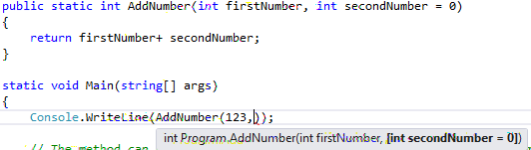

**Figure 1**: VisualStudio shows IntelliSense to implement Optional Parameter

What is Log4Net ?

* Log4net is an open source library that allows .NET applications to log output to a variety of sources i.e., Files, Databases,console, NT EventLog or even e-mail.
* In Simple terms, we can consume this Library and log the application errors to the required sources  without writing any code.

Advantages of Log4Net :

* Logging behavior can be set at runtime using a configuration file. Configuration files are in XML format.
* Log4net is thread-safe.
* It  categorizes logging into levels: DEBUG, INFO, WARN, ERROR and FATAL.
* The target of the log output as well as the writing strategy can be altered by writing a new appender class.
* It  supports multiple output appenders per logger.

2) What is Appenders and different types of Appenders in Log4Net?  
  
An appender is basically a destination that the logging information will go to.  Most frequently used Appenders are listed below:

|  |  |
| --- | --- |
| Appender Name | Description |
| AdoNetAppender | Appender that logs to a database. |
| EventLogAppender | Writes events to the system event log. |
| FileAppender | Appends logging events to a file. |
| SmtpAppender | Send an e-mail when a specific logging event occurs, typically on errors or fatal errors. |

## Integration Steps

Follows the steps to do the integration between Log4Net and C# Console application as example:

### Step 1

Open your Visual Studio instance on your PC.

### Step 2

Create a console project.

### Step 3

Add log4net refer to your project. We have 2 ways for adding that library. The first one is download the log4net from the internet to your local device, then add the reference to DLL file. The second one is download it from Nuget. I preferred this way by the following:

* Right clicks on your project
* Click Manage NuGet Packages…
* Clicks on Browse on the left hand
* Type log4net in search box under Browse option
* Select log4net package and click Install

### Step 4

Open AssemblyInfo.cs file under Properties, then add the below line of code under the [assembly: AssemblyCulture("")]line.

Hide   Copy Code

// Let log4net know that it can look for configuration in the default application config file

[assembly: log4net.Config.XmlConfigurator(Watch = true)]

### Step 5

Open the App.config file, by default after creating the console app, it will contain the following code:

Hide   Copy Code

<?xml version="1.0" encoding="utf-8" ?>

<configuration><supportedRuntime version="v4.0"

sku=".NETFramework,Version=v4.5.2"/>

</startup>

</configuration>

Next, add the configuration code for log4net into this file, but don't forget to add those configurations before <startup></startup> tag to make sure the log4net runs well. After that, it should be:

Hide   Shrink    Copy Code

<?xml version="1.0" encoding="utf-8" ?>

<configuration>

<configSections>

<section name="log4net"

type="log4net.Config.Log4NetConfigurationSectionHandler,Log4net"/>

</configSections>

<log4net>

<appender name="TestAppender"

type="log4net.Appender.RollingFileAppender">

<file value="E:\log\MyTestAppender.log"/>

<encoding value="utf-8"/>

<appendToFile value="true"/>

<rollingStyle value="Date"/>

*<!--<rollingStyle value="Size" />*

*<maxSizeRollBackups value="5" />*

*<maximumFileSize value="5MB" />*

*<staticLogFileName value="true" />-->*

<layout type="log4net.Layout.PatternLayout">

<conversionPattern value="%date %level [%thread] %type.%method - %message%n"/>

</layout>

</appender>

<root>

<level value="All"/>

*<!-- If the following line is not included the log file*

*will not be created even if log4net is configured with this file. -->*

<appender-ref ref="TestAppender"/>

</root>

</log4net>

<startup>

<supportedRuntime version="v4.0" sku=".NETFramework,Version=v4.5.2"/>

</startup>

</configuration>

I'm going to explain a little for the above configured.

This line of code...

Hide   Copy Code

<configSections><section name="**log4net**"

type="log4net.Config.Log4NetConfigurationSectionHandler, Log4net"/></configSections>

...lets the log4net know that the real configuration is stored in XML node called log4net, where we can setup the output log file, define the output layout for messages and set the roolingstyle for data file, etc.

### Step 6

Open the Program.cs file, by default, it contains only the Main (string [] args) method. Go ahead to create a method called ImplementLoggingFuntion, which implements the logging feature using log4net. The full code for Program.cs is as below:

Hide   Shrink    Copy Code

using System;

using log4net;

using System.Threading;

namespace Log4Net.CSharp

{

class Program

{

*//Declare an instance for log4net*

privatestaticreadonly ILog Log =

LogManager.GetLogger(System.Reflection.MethodBase.GetCurrentMethod().DeclaringType);

staticvoid Main(string[] args)

{

ImplementLoggingFuntion();

}

privatestaticvoid ImplementLoggingFuntion()

{

*/* We have 5 levels of log message. Let's test all.*

*\* FATAL*

*ERROR*

*WARN*

*INFO*

*DEBUG*

*\*/*

var secs = 3;

Log.Fatal("Start log FATAL...");

Console.WriteLine("Start log FATAL...");

Thread.Sleep(TimeSpan.FromSeconds(secs)); *// Sleep some secs*

Log.Error("Start log ERROR...");

Console.WriteLine("Start log ERROR...");

Thread.Sleep(TimeSpan.FromSeconds(secs)); *// Sleep some secs*

Log.Warn("Start log WARN...");

Console.WriteLine("Start log WARN...");

Thread.Sleep(TimeSpan.FromSeconds(secs)); *// Sleep some secs*

Log.Info("Start log INFO...");

Console.WriteLine("Start log INFO...");

Thread.Sleep(TimeSpan.FromSeconds(secs)); *// Sleep some secs*

Log.Debug("Start log DEBUG...");

Console.WriteLine("Start log DEBUG...");

Thread.Sleep(TimeSpan.FromSeconds(secs)); *// Sleep some secs*

Console.WriteLine("Press any key to close the application");

Console.ReadKey();

}

}

}

As I mentioned above, the conversion pattern entry is used for the pattern layout to tell the appender how to store the information. There are many different keywords that can be used in these patterns, as well as string literals. Here I will specify what I think are the most useful and important ones. The full list can be found in the log4net documentation.

* %date - Outputs the date using the local time zone information. This date can be formatted using the curly braces and a layout pattern such as %date{MMMM dd, yyyy HH:mm:ss, fff} to output the value of "January 01, 2011 14:15:43, 767". However, it is suggested that you use one of the log4net date formatters (ABSOLUTE, DATE, or ISO8601) since they offer better performance.
* %utcdate - This is the same as the %date modifier, but it outputs in universal time. The modifiers for date/time all work the same way.
* %exception - If an exception is passed in, it will be entered and a new line will be placed after the exception. If no exception is passed in, this entry will be ignored and no new line will be put in. This is usually placed at the end of a log entry, and usually a new line is placed before the exception as well.
* %level - This is the level you specified for the event (DEBUG, INFO, WARN, etc.).
* %message - This is the message you passed into the log event.
* %newline - This is a new line entry. Based upon the platform you are using the application on, this will be translated into the appropriate new line character(s). This is the preferred method to enter a new line and it has no performance problems compared to the platform-specific operators.
* %timestamp - This is the number of milliseconds since the start of the application.
* %thread - This will give you the name of the thread that the entry was made on (or the number if the thread is not named).

Beyond these are a few more that can be very useful but should be used with caution. They have negative performance implications and should be used with caution. The list includes:

* %location - Especially useful if you are running in Debug mode, this tells you where the log method was called (line number, method, etc.). However, the amount of information will decrease as you operate in Release mode depending on what the system can access from the compiled code.
* %line - This is the line number of the code entry (see the note above on the location issues).
* %method - This is the method that calls the log entry (see the note above on the location issues).
* %username - This outputs the value of the WindowsIdentity property.

**<appendToFile value="true"/>** tells Log4Net to put new entries at the end of the file.

**<rollingStyle value="Size" />** is specific for the RollingFileAppender, and specifies the criteria type for when it should "roll" i.e. create a new file. In this case we will specify a max file size.

**<maxSizeRollBackups value="2" />** is for specifying the maximum number of log files to keep. In this case, it will not keep more than two log files.

The **<maximumFileSize value="1MB" />** element lets us set a log file size limit, which is nice if you want to keep control of disk space usage. In combination with the above element, it will keep two files with a maximum size each of 1MB.

**<staticLogFileName value="true" />** means that it will not change the file name, just the extension.

In the class you want to use logging, add the following property:

private readonly ILog log = LogManager.GetLogger(MethodBase.GetCurrentMethod().DeclaringType);

This will create a logger with the same name as the full name of your class. I will show you how to utilize that later.

To perform logging now, you can just do like this:

**this**.log.Debug ("Debug message");

**this**.log.Info("Info message");

**this**.log.Warn("Warning message");

**this**.log.Error("Error message");

**this**.log.Fatal("Fatal message");

# Difference between ref and out parameters

Ref

The ref keyword is used to pass an argument as a reference. This means that when value of that parameter is changed in the method, it gets reflected in the calling method. An argument that is passed using a ref keyword must be initialized in the calling method before it is passed to the called method.

Out

The out keyword is also used to pass an argument like ref keyword, but the argument can be passed without assigning any value to it. An argument that is passed using an out keyword must be initialized in the called method before it returns back to calling method.

### Program with ref and out keyword

1. publicclassExample
2. {
3. publicstaticvoidMain()*//calling method*
4. {
5. int val1 =0;*//must be initialized*
6. int val2;*//optional*
8. Example1(ref val1);
9. Console.WriteLine(val1);*// val1=1*
11. Example2(out val2);
12. Console.WriteLine(val2);*// val2=2*
13. }
15. staticvoidExample1(ref int value)*//called method*
16. {
17. value =1;
18. }
19. staticvoidExample2(out int value)*//called method*
20. {
21. value =2;*//must be initialized*
22. }
23. }
25. */* Output*
26. *1*
27. *2*
28. *\*/*

Ref and out in method overloading

Both ref and out cannot be used in method overloading simultaneously. However, ref and out are treated differently at run-time but they are treated same at compile time (CLR doesn't differentiates between the two while it created IL for ref and out). Hence methods cannot be overloaded when one method takes a ref parameter and other method takes an out parameter. The following two methods are identical in terms of compilation.

1. classMyClass
2. {
3. Public void Method(out int a)*// compiler error “cannot define overloaded”*
4. {
5. *// method that differ only on ref and out"*
6. }
7. Public void Method(ref int a)
8. {
9. *// method that differ only on ref and out"*
10. }
11. }

However, method overloading can be done, if one method takes a ref or out argument and the other method takes simple argument. The following example is perfectly valid to be overloaded.

1. classMyClass
2. {
3. publicvoidMethod(int a)
4. {
6. }
7. publicvoidMethod(out int a)
8. {
9. *// method differ in signature.*
10. }
11. }

# Encapsulation

Encapsulation is used to hide data and behavior that are not necessary from outside class or interface.Encapsulation enables a group of properties, methods and other members to be considered a single unit or object.In C# programming, Encapsulation uses five types of modifier to encapsulate data. These modifiers are public, private, internal, protected and protected internal.

The following are the benefits of encapsulation:

* Protection of data from accidental corruption
* Specification of the accessibility of each of the members of a class to the code outside the class
* Flexibility and extensibility of the code and reduction in complexity
* Lower coupling between objects and hence improvement in code maintainability

Encapsulation in C# is implemented with different levels of access to object data that can be specified using the following access modifiers:

* Public: Access to all code in the program
* Private: Access to only members of the same class
* Protected: Access to members of same class and its derived classes
* Internal: Access to current assembly
* Protected Internal: Access to current assembly and types derived from containing class

C# allows encapsulation of data through the use of accessors (to get data) and mutators (to modify data), which help in manipulating private data indirectly without making it public. Properties are an alternate mechanism for private data to be encapsulated in a C# object and accessed in either read-only mode or in read-write mode. Unlike the accessor and mutator, a property provides a single point of access to an object's "set" and "get" values.

Can you overload static constructor

No, because you cannot invoke a static constructor explicitly, it is invoked implicitly by the run time before the objects are instantiated. Also, you cannot pass any parameters to a static constructor(its always parameter less) therefore it cannot be overloaded.

STATIC METHOD CAN BE OVERLOADING AND OVERIDNG

Static Methods can't be override because static methods can only be accessed using class name and are inaccessible to the objects of the class. So no question of overriding.

In C# Static Method is Overloaded but not override because override always used in drive class.but in case of static can not provide inheritance.

# handle exceptions in finally block C#

publicclass ABC

{

public ABC(int abc)

{

}

public ABC()

{

}

}

publicclass XYZ : ABC

{

public XYZ(string k)

{

}

public XYZ()

{

}

}

publicclass C : XYZ

{

public C(string k)

{

}

}

classProgram

{

staticvoidMain(string[] args)

{

try

{

C objXYZ =new C("ABC");

}

catch(Exception ex)

{}

finally

{

try

{

thrownewException();

}

catch(Exception ex)

{

}

finally

{

}

}

}

}

**when to use interface and abstract class in c#**

Now, I have  class like Hyundai and Toyota which are derived from a parent class called Car. Here, I have the car methods as follow:

1. **public**  **class** Cars
2. {
4. **public** **string** Wheel()
5. {
6. **return** "4 wheeler";
8. }
9. **public** **string** CheckAC()
10. {
11. **return** "AC is available";
12. }
13. **public** **string** CallFacility()
14. {
15. **return** "Call Facility  supported";
16. }
18. }

Here, I have 2 types of cars which are inherited from Cars.

1. **using** oops1;
2. **using** System;
3. **using** System.Collections.Generic;
4. **using** System.Linq;
5. **using** System.Text;
6. **using** System.Threading.Tasks;
8. **namespace** oops1
9. {
10. **public** **class** Hyundai : Cars
11. {
13. **static** **void** Main(**string**[] args)
14. {
15. Hyundai dust = **new** Hyundai();
17. Console.WriteLine(dust.CallFacility());
18. Console.WriteLine(dust.Wheel());
19. Console.WriteLine(dust.CheckAC());
20. Console.ReadLine();

23. }
24. }

27. }

Now, it runs as expected and gives the following output .  
  
   
  
Similarly, as Toyota is a car and it also inherits from Cars class.

1. **using** System;
2. **using** System.Collections.Generic;
3. **using** System.Linq;
4. **using** System.Text;
5. **using** System.Threading.Tasks;
7. **namespace** oops1
8. {
9. **public** **class** Toyota : Cars
10. {
11. **public** **string** DiscountPrice()
12. {
13. **return** "20% discount on buying Toyoya Cars";
14. }

17. **static** **void** Main(**string**[] args)
18. {
19. Toyota Toy = **new** Toyota();
21. Console.WriteLine(Toy.CallFacility());
22. Console.WriteLine(Toy.Wheel());
23. Console.WriteLine(Toy.CheckAC());
24. Console.WriteLine(Toy.DiscountPrice());
26. Console.ReadLine();

29. }
30. }
31. }

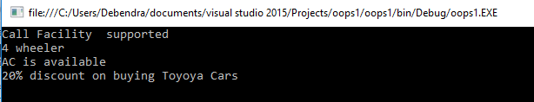

We need some methods which are common to both the classes but their implementation is different.

* **PRICE**()- Both have price but different price.
* **TotalSeat**()- Both have total seats but different no. of seats.
* **colors**()- Both cars are of different colour.

So, here are the options for implementing these methods in both classes.

* Can I go for a normal class?
* Should I use interface here?
* Can I use an abstract class?



* If we are taking class, then we can only write normal methods having common implementation there. But, this will not satisfy our requirement because we need separate implementations in both the classes. Thus, we will not go forward with Class.
* 

If we go for interface, we can achieve our goal but it will be like this. First, I will declare n interface, as follows.

1. **interface** IExtra
2. {
3. **double** price();
4. **int** getTotalSeat();
5. **string** colors();
6. }

Now, let me first inherit the Toyota class from Cars class and IExtra interface class to achieve our goal.  
  
The code is given below.

1. **namespace** oops1
2. {
3. **public** **class** Toyota : **Cars**,**IExtra**
4. {
5. **public** **string** DiscountPrice()
6. {
7. **return** "20% discount on buying Toyoya Cars";
8. }
9. **public**  **double** price()
10. {
11. **return** 1000000.00;
12. }
13. **public**  **int** getTotalSeat()
14. {
15. **return** 5;
16. }
17. **public** **string** colors()
18. {
19. **return** "Red";
20. }
22. **static** **void** Main(**string**[] args)
23. {
24. Toyota Toy = **new** Toyota();
26. Console.WriteLine(Toy.CallFacility());
27. Console.WriteLine(Toy.Wheel());
28. Console.WriteLine(Toy.CheckAC());
29. Console.WriteLine(Toy.DiscountPrice());
30. Console.WriteLine("Total ONRoad Price:"+ Toy.price());
31. Console.WriteLine(Toy.getTotalSeat());
32. Console.WriteLine(Toy.colors());
34. Console.ReadLine();

37. }
38. }

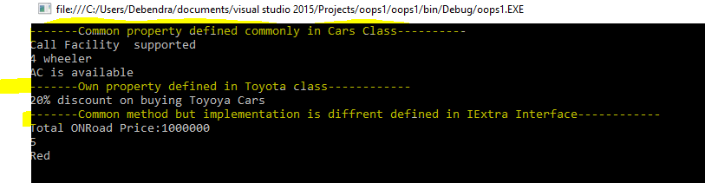    
  
So, the sketch diagram of this implementation will be like this.

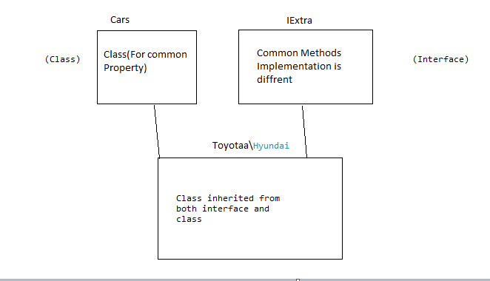

**Abstract Class**

Now, we will see here how we can solve our problem using Abstract Class.

* 1. Define an abstract class as Car.
  2. 2. Put all the common functionality in simple methods and all the methods whose implementation is different but name is same. Make them  Abstract method.

Here is my Car abstract class.

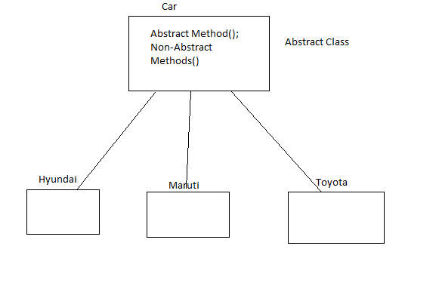

1. **using** System;
2. **using** System.Collections;
3. **using** System.Collections.Generic;
5. **namespace** oops1
6. {
7. **public** **abstract**  **class** Cars
8. {
10. //put all the common functions but diffrent implementation in  abstract method.
11. **public** **abstract** **double** price();
12. **public** **abstract** **int** getTotalSeat();
13. **public** **abstract** **string** colors();
15. //put all the common property in normal class
16. **public** **string** Wheel()
17. {
18. **return** "4 wheeler";
20. }
21. **public** **string** CheckAC()
22. {
23. **return** "AC is available";
24. }
25. **public** **string** CallFacility()
26. {
27. **return** "Call Facility  supported";
28. }
29. }
30. }

Now, here is my Toyota class which is derived from Cars abstract class.

1. **using** System;
2. **using** System.Collections.Generic;
3. **using** System.Linq;
4. **using** System.Text;
5. **using** System.Threading.Tasks;
7. **namespace** oops1
8. {
9. **public** **class** Toyota : **Cars**
10. {
11. **public** **string** DiscountPrice()
12. {
13. **return** "20% discount on buying Toyoya Cars";
14. }
15. **public** **override** **double** price()
16. {
17. **return** 1000000.00;
18. }
19. **public** **override** **int** getTotalSeat()
20. {
21. **return** 5;
22. }
23. **public** **override** **string** colors()
24. {
25. **return** "Red";
26. }
28. **static** **void** Main(**string**[] args)
29. {
30. Toyota Toy = **new** Toyota();
31. Console.WriteLine("-------Common property defined commonly in Cars Class----------");
33. Console.WriteLine(Toy.CallFacility());
34. Console.WriteLine(Toy.Wheel());
35. Console.WriteLine(Toy.CheckAC());
36. Console.WriteLine("-------Own property defined in Toyota class------------");
37. Console.WriteLine(Toy.DiscountPrice());
38. Console.WriteLine("-------Common method but implementation is diffrent defined in IExtra Interface------------");
39. Console.WriteLine("Total ONRoad Price:"+ Toy.price());
40. Console.WriteLine(Toy.getTotalSeat());
41. Console.WriteLine(Toy.colors());
43. Console.ReadLine();

46. }
47. }

50. }

**Conclusion**When we have the requirement of a class that contains some common properties or methods with some common properties whose implementation is different for different classes, in that situation, it's better to use Abstract Class then Interface.

**When To Use Interface In Real Time Project?**

 I will go for the same example that I have done earlier.

1. **using** System;
2. **using** System.Collections;
3. **using** System.Collections.Generic;
5. **namespace** oops1
6. {
7. **public**   **class** Cars
8. {
10. **public** **string** Wheel()
11. {
12. **return** "4 wheeler";
14. }
15. **public** **string** CheckAC()
16. {
17. **return** "AC is available";
18. }
19. **public** **string** CallFacility()
20. {
21. **return** "Call Facility  supported";
22. }




28. }

31. }

Now, here is my Toyota class which is derived from Cars.

1. **using** System;
2. **using** System.Collections.Generic;
3. **using** System.Linq;
4. **using** System.Text;
5. **using** System.Threading.Tasks;
7. **namespace** oops1
8. {
9. **public** **class** Toyota : Cars
10. {

13. **static** **void** Main(**string**[] args)
14. {

17. Toyota Toy = **new** Toyota();


21. Console.WriteLine(Toy.CallFacility());
22. Console.WriteLine(Toy.Wheel());
23. Console.WriteLine(Toy.CheckAC());


27. Console.ReadLine();

30. }
31. }

34. }

Here is my Hyundai class which is derived from Cars.

1. **using** oops1;
2. **using** System;
3. **using** System.Collections.Generic;
4. **using** System.Linq;
5. **using** System.Text;
6. **using** System.Threading.Tasks;
8. **namespace** oops1
9. {
10. **public** **class** Hyundai:Cars
11. {

14. **static** **void** Main(**string**[] args)
15. {
16. Hyundai dust = **new** Hyundai();
18. Console.WriteLine(dust.CallFacility());
19. Console.WriteLine(dust.Wheel());
20. Console.WriteLine(dust.CheckAC());

23. Console.ReadLine();

26. }
27. }

30. }

A new feature for the Hyundai car is Introduced called GPS which is not supported in Toyota cars. Then, how can we implement and which way we can implement these?  
  
Here, we have certain options like

* Go for a new class defining the GPS method and inherit it to the Hyundai Class.
* Go for an abstract class and define GPS method and inherit it on Hyundai class and implement the GPS method there.
* Directly create a method in Hyundai class and consume it.
* Go for Interface
* **CASE 1 - By Using simple class**  
  Let's find what will happen if we use a class there, and declare a method as GPS and try to inherit in Hyundai class.  
  Created a new class as "NewFeatures, as shown below.
  1. **class** NewFeatures
  2. {
  3. **public** **void** GPS()
  4. {
  5. Console.WriteLine("GPS supported");
  6. }
  7. }

Now, inherit the Hyundai class from NewFeatures. So, if we check this class, it was previously inherited from Cars class and for now, again inherits from NefFeatures class. So, it gives the following error when you try to run the program.

* 1. **using** oops1;
  2. **using** System;
  3. **using** System.Collections.Generic;
  4. **using** System.Linq;
  5. **using** System.Text;
  6. **using** System.Threading.Tasks;
  8. **namespace** oops1
  9. {
  10. **public** **class** Hyundai:Cars,NewFeatures
  11. {

  14. **static** **void** Main(**string**[] args)
  15. {
  16. Hyundai hun = **new** Hyundai();
  18. Console.WriteLine(hun.CallFacility());
  19. Console.WriteLine(hun.Wheel());
  20. Console.WriteLine(hun.CheckAC());

  23. Console.ReadLine();

  26. }
  27. }

  30. }

Now, run the program and find out the error.  
  
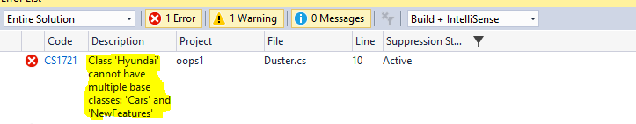  
  
This is simple because C# does not support multiple inheritance.

**CASE 2 - By using Abstract class**  
  
Now, go for abstract class and see what happens.

1. **public** **abstract** **class**  NewFeatures
2. {
3. **abstract** **public** **void** GPS();
5. }

Now, let's try to inherit from abstract class.

1. **using** oops1;
2. **using** System;
3. **using** System.Collections.Generic;
4. **using** System.Linq;
5. **using** System.Text;
6. **using** System.Threading.Tasks;
8. **namespace** oops1
9. {
10. **public** **class** Hyundai:Cars,NewFeatures
11. {
12. **public**  **override**  **void** GPS()
13. {
14. Console.WriteLine("GPS supported.");
16. }

19. **static** **void** Main(**string**[] args)
20. {
21. Hyundai hun = **new** Hyundai();
23. Console.WriteLine(hun.CallFacility());
24. Console.WriteLine(hun.Wheel());
25. Console.WriteLine(hun.CheckAC());

28. Console.ReadLine();

31. }
32. }

35. }

So, here is the error I got.  
  
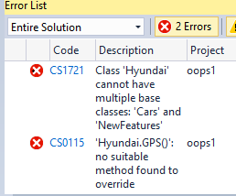

**CASE 3 - Direct creating a method called GPS() inside Hyundai class**  
This is very relevant way to use a unique method but it has a small problem. If for any reason we forget to create such common method, then it will not ask to write methods.Today, we are using one unique method so that is OK we can remember and write the method. Suppose, we have hundreds of such common methods and we forget to  write 2 of them then it will run but not give the expected output,so we have to skip the way and go for the fourth one by defining interface.

**CASE 4 - By defining Interface**  
This is the most important case and we will see how it will solve our problem.Lets define  the  method in an Interface

1. **interface  INewFeatures**
2. **{**
3. **void GPS();**
5. **}**

Now inherit the Interface from Cars and see without implementing the GPS() method.

1. **using oops1;**
2. **using System;**
3. **using System.Collections.Generic;**
4. **using System.Linq;**
5. **using System.Text;**
6. **using System.Threading.Tasks;**
8. **namespace oops1**
9. **{**
10. **public class Hyundai:Cars, INewFeatures**
11. **{**

14. **static void Main(string[] args)**
15. **{**
16. **Hyundai hun = new Hyundai();**
18. **Console.WriteLine(hun.CallFacility());**
19. **Console.WriteLine(hun.Wheel());**
20. **Console.WriteLine(hun.CheckAC());**

23. **Console.ReadLine();**

26. **}**
27. **}**

30. **}**

As we have not implemented the method it will show the following error as follow.  
  
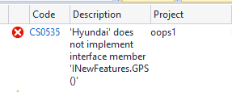So, the problems which happen in case 3 can be easily solved by using Interface. Now, let's implement the method and see will it solve the problem which arises in Case1 and case2 as follows.

1. **using oops1;**
2. **using System;**
3. **using System.Collections.Generic;**
4. **using System.Linq;**
5. **using System.Text;**
6. **using System.Threading.Tasks;**
8. **namespace oops1**
9. **{**
10. **public class Hyundai:Cars,INewFeatures**
11. **{**
12. **public  void GPS()**
13. **{**
14. **Console.WriteLine("GPS supported.");**
16. **}**

19. **static void Main(string[] args)**
20. **{**
21. **Hyundai hun = new Hyundai();**
23. **Console.WriteLine(hun.CallFacility());**
24. **Console.WriteLine(hun.Wheel());**
25. **Console.WriteLine(hun.CheckAC());**
26. **hun.GPS();**

29. **Console.ReadLine();**

32. **}**
33. **}**

36. **}**

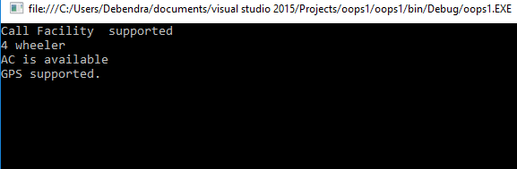

Thus, it resolves the demerits of all the above 3 cases. So, in this situation, we have to use Interface. Here, I have shown you the sketch diagram.  
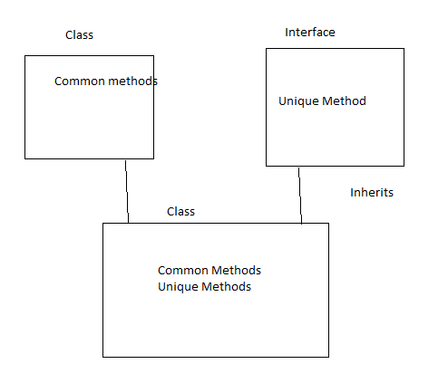

# Destructor in C#

Destructors are used to destruct instances of classes.

In C# you can never call them, the reason is one cannot destroy an object. So who has the control over the destructor (in C#)? it's the .NET frameworks Garbage Collector (GC).

**Syntax of Destructor(~)**~ ClassName()

using System;  
namespace destructorex  
{  
    class Program  
    {  
        ~Program() // destructor define   
        {   
           // clean up statement  
        }  
    }  
}

**Characteristics of  Destructor**

* Destructor cannot be inherited or overloaded.
* Destructor does not take modifiers or have parameters.
* Destructor cannot be called. They are invoked automatically.
* An instance becomes eligible for destruction when it is no longer possible for any code to use the instance.
* The Programmer has no control over when destructor is called because this is determined by Garbage Collector.
* Destructor is called when program exits.
* Execution of the destructor for the instance may occur at any time after the instance becomes eligible for destruction.
* Destructor implicitly calls Finalize on the base class of object.

**Note**: **Execution order:**Base constructor is getting called first. In general, destructors are called in the reverse order of the constructor calls.

**Program of Execution order**class First  
{  
    ~First()  
    {  
        System.Console.WriteLine("First's destructor is called");  
    }  
}

class Second : First  
{  
    ~Second()  
    {  
        System.Console.WriteLine("Second's destructor is called");  
    }  
}

class Third : Second  
{  
    ~Third()  
    {  
        System.Console.WriteLine("Third's destructor is called");  
    }  
}

class TestDestructors  
{  
    static void Main()  
    {  
        Third t = new Third();  
    }  
}

**Output  
  
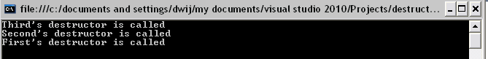**

**We can define the Inner class in the C#**

using System;

using System.Collections.Generic;

using System.Linq;

using System.Text;

using System.Threading.Tasks;

namespace ConsoleApplication1

{

class Program

{

public void getMessage1()

{

Console.WriteLine("Program Class");

}

class Employee

{

public void getMessage()

{

Console.WriteLine("Employee Class");

}

}

static void Main(string[] args)

{

Program P = new Program();

P.getMessage1();

Program.Employee e = new Program.Employee();

e.getMessage();

}

}

}

**Output:**

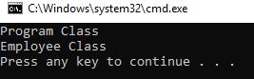

**Difference between struct and class:**

* Struct are the value type and class is reference type.
* Struct cannot have a default constructor (a constructor without parameters) or a destructor.
* A struct cannot inherit from another struct or class, and it cannot be the base of a class. All structs inherit directly from System.ValueType, which inherits from System.Object.
* Struct cannot be a base class. So, Struct types cannot abstract and are always implicitly sealed.
* A static constructor is triggered in the case of a class but not in the case of a structure as in the following,
* **struct** myStructure
* {
* **static** myStructure()
* {
* Console.WriteLine("This is me a structure");
* }
* }
* **class** myClass
* {
* **static** myClass()
* {
* Console.WriteLine("This is me a class");
* }
* }
* **class** Program
* {
* **static** **void** Main(**string**[] args)
* {
* myStructure s =**new** myStructure();//Nothing happen
* myClass c =**new** myClass();//Will out put This is me a class
* Console.Read();
* }
* }
* Fields are automatically initialized with classes to 0/false/null whether as structures are not.
* Fields can't be directly instantiated within structures but classes allow such operations as in the following,

1. **struct** myStructure
2. {
3. **public** **string** x = 2;//Not allowed
4. }
5. **class** myClass
6. {
7. **public** **string** x = 2;//Allowed
8. }

What is Task in C#?

.NET framework provides Threading.Tasks class to let you create tasks and run them asynchronously. A task is an object that represents some work that should be done. The task can tell you if the work is completed and if the operation returns a result, the task gives you the result.

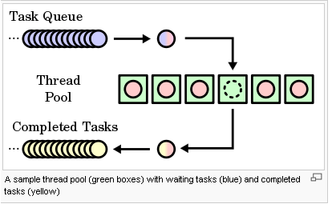

What is Thread?

.NET Framework has thread-associated classes in System.Threading namespace.  A Thread is a small set of executable instructions.

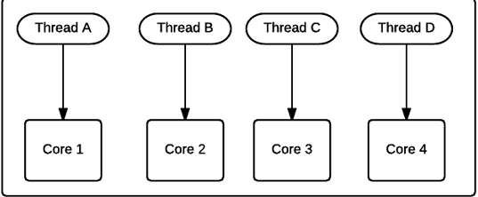

**Why we need Tasks**

 It can be used whenever you want to execute something in parallel. Asynchronous implementation is easy in a task, using’ async’ and ‘await’ keywords.

**Why we need a Thread**

When the time comes when the application is required to perform few tasks at the same time.

How to create a Task

1. **static** **void** Main(string[] args) {
2. Task < string > obTask = Task.Run(() => (
3. **return**“ Hello”));
4. Console.WriteLine(obTask.result);
5. }

How to create a Thread

1. **static** **void** Main(string[] args) {
2. Thread thread = **new** Thread(**new** ThreadStart(getMyName));
3. thread.Start();
4. }
5. **public** **void** getMyName() {}

Differences Between Task And Thread

Here are some differences between a task and a thread.

1. The Thread class is used for creating and manipulating a [thread](http://msdn.microsoft.com/en-us/library/windows/desktop/ms684841%28v=vs.85%29.aspx) in Windows. A [Task](http://msdn.microsoft.com/en-us/library/vstudio/system.threading.tasks.task) represents some asynchronous operation and is part of the [Task Parallel Library](http://msdn.microsoft.com/en-us/library/dd460717%28v=vs.110%29.aspx), a set of APIs for running tasks asynchronously and in parallel.
2. The task can return a result. There is no direct mechanism to return the result from a thread.
3. Task supports cancellation through the use of cancellation tokens. But Thread doesn't.
4. A task can have multiple processes happening at the same time. Threads can only have one task running at a time.
5. We can easily implement Asynchronous using ’async’ and ‘await’ keywords.
6. A new Thread()is not dealing with Thread pool thread, whereas Task does use thread pool thread.

# Element Operators: Single & SingleOrDefault

Single() returns the only element from a collection, or the only element that satisfies the specified condition. If a given collection includes no elements or more than one elements then Single() throws InvalidOperationException.

The SingleOrDefault() method does the same thing as Single() method. The only difference is that it returns default value of the data type of a collection if a collection is empty, includes more than one element or finds no element or more than one element for the specified condition.

Consider a class Employee with properties as Id, Name, and Department.

1. **class** Employee
2. {
3. **public** **int** Id { **get**; **set**; }
4. **public** **string** Name { **get**; **set**; }
5. **public** **string** Department{ **get**; **set**; }
6. }

I have a list of Employees:

1. List<Employee> employeeList = **new** List<Employee>(){
2. **new** Employee() { Id = 1, Name = "Sunny", Department = "Technical" },
3. **new** Employee() { Id=2, Name="Pinki", Department ="HR"},
4. **new** Employee() { Id=3, Name="Tensy", Department ="Finance"},
5. **new** Employee() { Id=4, Name="Bobby", Department ="Technical"},
6. **new** Employee() { Id=5, Name="Sweety", Department ="HR"}
7. };

**Single()**

1. It returns the only item of a sequence.
2. This will throw an exception if the result contains 0 or more than 1 elements.
3. We should use it, when we know that exactly one element is expected but neither 0 nor 2 or more.

**Example 1**

1. var result = employeeList.Single(e=>e.Id==1);

Will return:

1. Employee() { Id = 1, Name = "Sunny", Department = "Technical" }

**Example 2**

1. var result = employeeList.FirstOrDefault(e=>e.Department== "HR");

Will throw an exception as 2 employees exist with Department as "HR".

**Example 3**

1. var result = employeeList.Single(e=>e.Id == 8);

Will throw an exception as no employee exists with Id as 8.

**SingleOrDefault()**

1. It returns single specific element, and if the element is not found, it returns the default value of it.
2. This will throw an exception if the result contains 2 or more elements.
3. We should use it when we know that 0 or 1 element is expected as result.

**Example 1**

1. var result = employeeList.SingleOrDefault(e=>e.Id == 1);

Will return

1. Employee() { Id = 1, Name = "Sunny", Department = "Technical" }

**Example 2**

1. var result = employeeList.SingleOrDefault(e=>e.Department== "HR");

Will throw an exception as 2 employees exist with Department as HR in employeeList.

**Example 3**

1. var result = employeeList.SingleOrDefault(e=>e.Id == 8);

Will not throw an exception but it returns the default value of Employee.

**First()**

1. It returns the first element of a sequence.
2. It throws an error when there is no element in the result, or source is null.
3. We should use it if more than one element is expected and you want only the first element.

**Ex 1**

1. var result = employeeList.First();

Will return

1. Employee() { Id = 1, Name = "Sunny", Department = "Technical" }

**Ex 2**

1. var result = employeeList.First(e=>e.Department== "HR");

Will return

1. Employee() { Id=2, Name="Pinki", Department ="HR"}

**Ex 3**

1. var result = employeeList.First(e=>e.Id == 8);

This will throw an error, because employee with Id as 8 does not exist in the employeeList.

**FirstOrDefault()**

1. It returns the first element of a sequence, or a default value if no element is found.
2. It throws an error only if the source is null.
3. We should use it if more than one element is expected and you want only the first element. It's also good if the result is empty.

**Example 1**

1. var result = employeeList.FirstOrDefault();

Will return:

1. Employee() { Id = 1, Name = "Sunny", Department = "Technical" }

**Example 2**

1. var result = employeeList.FirstOrDefault(e=>e.Department== "HR");

Will return:

1. Employee() { Id=2, Name="Pinki", Department ="HR"}

**Example 3**

1. var result = employeeList.FirstOrDefault(e=>e.Id == 8);

Will not throw an error but it returns default value of Employee.

# What are the SOLID principles in C#?

### Single responsibility principle​ (SRP)

SRP states that every class must have only one reason to change it. In other words, each class must be responsible for a single purpose only. Consider the following code snippet, featuring a User class with an update method:

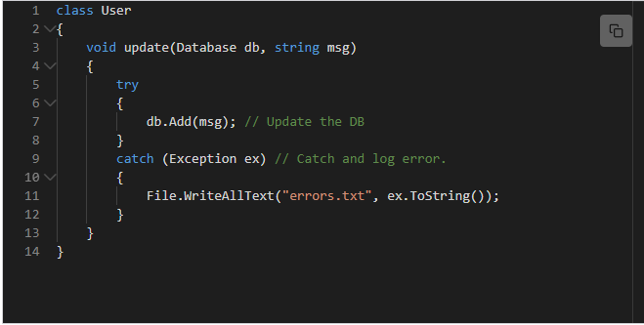

The User class is not only updating the database, ​its also handling logging of errors.

Consider the SRP compliant code below:

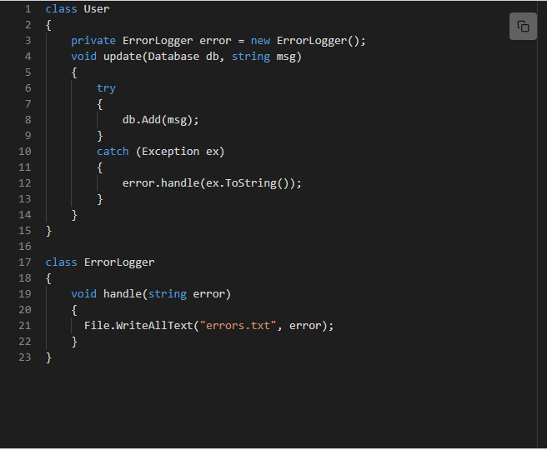

Class User's responsibility is to update the database. Class ErrorHandler logs errors.

### Open closed principle (OCP)

OCP states that classes must be open for extension, but closed for modification:

Now take ‘ReportGeneration’ class as an example of this principle. Can you guess what is the problem with the be

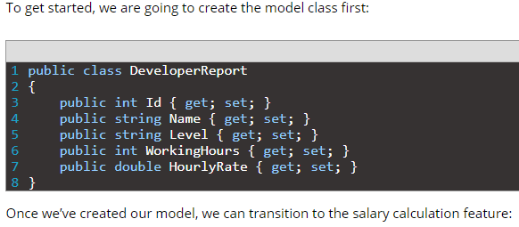

#### 

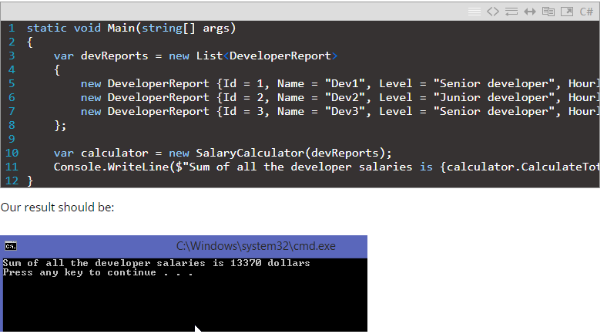

So, all of this is working great, but now our boss comes to our office and says that we need a different calculation for the senior and junior developers. The senior developers should have a bonus of 20% on a salary.

Of course, to satisfy this requirement, we are going to modify our CalculateTotalSalaries method like this:

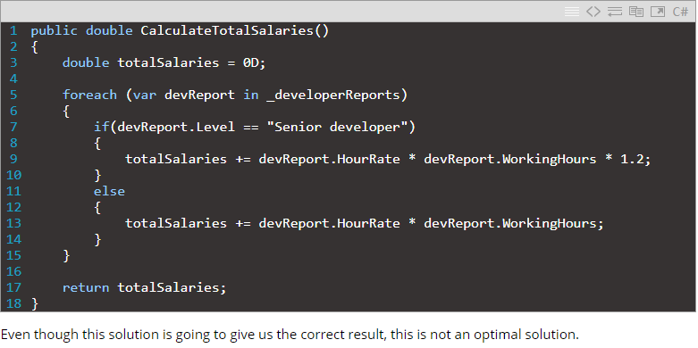

Why is that?

Mainly, because we had to modify our existing class behavior which worked perfectly. Another thing is that if our boss comes again and ask us to modify calculation for the junior dev’s as well, we would have to change our class again. This is totally against of what OCP stands for.

It is obvious that we need to change something in our solution, so, let’s do it.

**Better Salary Calculator Example – OCP implemented**

To create a code that abides by the Open Closed Principle, we are going to create an abstract class first:

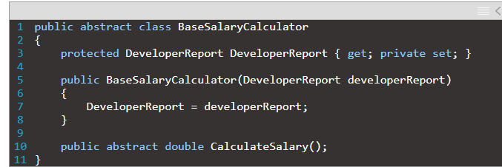

As a continuation, we are going to create two classes which will inherit from the BaseSalaryCalculator class. Because it is obvious that our calculation depends on the developer’s level, we are going to create our new classes in that manner:

|  |  |
| --- | --- |
| 1  2  3  4  5  6  7  8  9 | public class SeniorDevSalaryCalculator : BaseSalaryCalculator  {      public SeniorDevSalaryCalculator(DeveloperReport report)          :base(report)      {      }        public override double CalculateSalary() => DeveloperReport.HourlyRate * DeveloperReport.WorkingHours * 1.2;  } |
| 1  2  3  4  5  6  7  8  9 | public class JuniorDevSalaryCalculator : BaseSalaryCalculator  {      public JuniorDevSalaryCalculator(DeveloperReport developerReport)          :base(developerReport)      {      }        public override double CalculateSalary() => DeveloperReport.HourlyRate * DeveloperReport.WorkingHours;  } |

Excellent. Now we can modify the SalaryCalculator class:

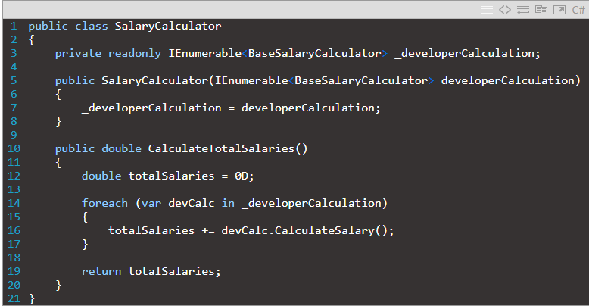

This looks so much better because we won’t have to change any of our current classes if our boss comes with another request about the intern payment calculation or any other as well.

All we have to do now is to add another class with its own calculation logic. So basically, our SalaryCalculator class is now closed for modification and opened for an extension, which is exactly what OCP states.

To finish this example, let’s modify the Program.cs class:

|  |  |
| --- | --- |
| 1  2  3  4  5  6  7  8  9  10  11  12  13  14  15 | class Program  {      static void Main(string[] args)      {          var devCalculations = new List<BaseSalaryCalculator>          {              new SeniorDevSalaryCalculator(new DeveloperReport {Id = 1, Name = "Dev1", Level = "Senior developer", HourlyRate = 30.5, WorkingHours = 160 }),              new JuniorDevSalaryCalculator(new DeveloperReport {Id = 2, Name = "Dev2", Level = "Junior developer", HourlyRate = 20, WorkingHours = 150 }),              new SeniorDevSalaryCalculator(new DeveloperReport {Id = 3, Name = "Dev3", Level = "Senior developer", HourlyRate = 30.5, WorkingHours = 180 })          };            var calculator = new SalaryCalculator(devCalculations);          Console.WriteLine($"Sum of all the developer salaries is {calculator.CalculateTotalSalaries()} dollars");      }  } |

#### 2.3 Liskov substitution principle (LSP)

This principle is simple but very important to understand. Child class should not break parent class’s type definitionand behavior. Now what is the meaning of this!! Ok let me take the same employee example to make you understand this principle. Check the below picture. Employee is a parent class and Casual and Contractual employee are the child classes, inhering from employee class.

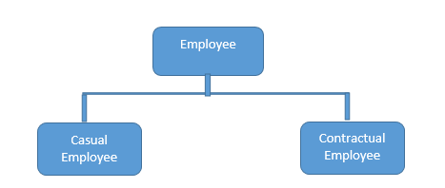

Now see the below code:

public abstract class Employee

{

public virtual string GetProjectDetails(int employeeId)

{

return "Base Project";

}

public virtual string GetEmployeeDetails(int employeeId)

{

return "Base Employee";

}

}

public class CasualEmployee : Employee

{

public override string GetProjectDetails(int employeeId)

{

return "Child Project";

}

*// May be for contractual employee we do not need to store the details into database.*

public override string GetEmployeeDetails(int employeeId)

{

return "Child Employee";

}

}

public class ContractualEmployee : Employee

{

public override string GetProjectDetails(int employeeId)

{

return "Child Project";

}

*// May be for contractual employee we do not need to store the details into database.*

public override string GetEmployeeDetails(int employeeId)

{

throw new NotImplementedException();

}

}

Up to this is fine right? Now, check the below code and it will violate the LSP principle.

Hide   Copy Code

List<Employee> employeeList = new List<Employee>();

employeeList.Add(new ContractualEmployee());

employeeList.Add(new CasualEmployee());

foreach (Employee e in employeeList)

{

e.GetEmployeeDetails(1245);

}

Now I guess you got the problem. Yes right, for contractual employee, you will get not implemented exception and that is violating LSP. Then what is the solution? Break the whole thing in 2 different interfaces, 1. IProject 2. IEmployee and implement according to employee type.

public interface IEmployee

{

string GetEmployeeDetails(int employeeId);

}

public interface IProject

{

string GetProjectDetails(int employeeId);

}

Now, contractual employee will implement IEmployee not IProject. This will maintain this principle.

### Interface segregation principle (ISP)

ISP suggests that several specific client interfaces are better than having one general interface. In other words, it is better to have multiple interfaces instead of adding lots of functionality to one interface.

Consider the example below:

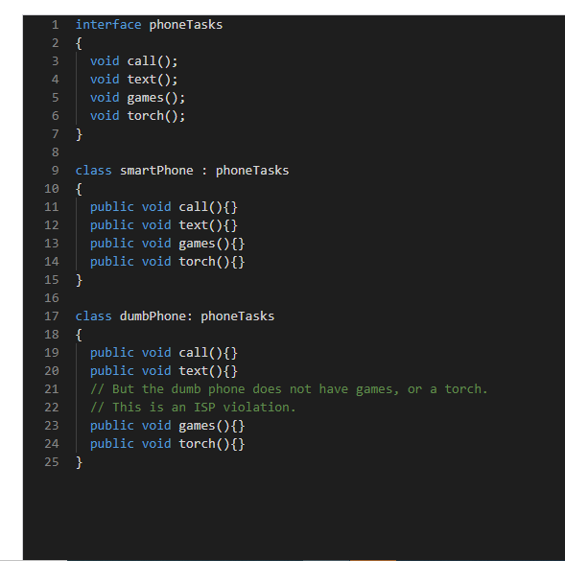

The interface phoneTasks has methods for tasks that a smartphone can perform; however, another phone may not have all of these features​ but is still implementing them.

Now consider the ISP compliant code below:

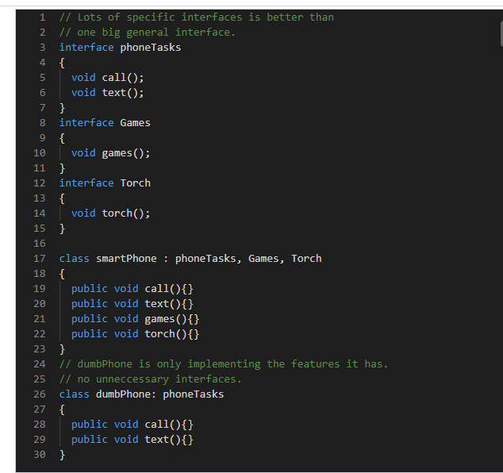

#### Dependency inversion principle (DIP)

High level modules should not depend on low-level modules, but should depend on abstraction.

This principle tells you not to write any tightly coupled code because that is a nightmare to maintain when the application is growing bigger and bigger. If a class depends on another class, then we need to change one class if something changes in that dependent class. We should always try to write loosely coupled class.

Suppose there is one notification system after saving some details into database.

##### Bad Way

Bad: We are relying on the customer to say that we are using a File Logger, rather than another type of logger, e.g. EmailLogger.

class FileLogger

{

void Handle(string error)

{

File.WriteAllText(@"C:\Error.txt", error);

}

}

internal class Customer

{

FileLogger logger = new FileLogger(); // Bad

public void Add(Database db)

{

try

{

db.Add();

}

catch (Exception error)

{

logger.Handle(error.ToString());

}

}

}

##### Good Way

Good: We pass in a Logger interface to the customer so it doesnt know what type of logger it is

class BetterCustomer

{

ILogger logger;

BetterCustomer(ILogger logger)

{

this.logger = logger;

}

void Add(Database db)

{

try

{

db.Add();

}

catch (Exception error)

{

logger.Handle(error.ToString());

}

}

}

class EmailLogger : ILogger

{

void Handle(string error)

{

File.WriteAllText(@"C:\Error.txt", error);

}

}

interface ILogger

{

void Handle(string error);

}

**CLR VS CoreCLR**

**CLR**

Common Language Runtime.

The exact meaning depends on the context, but Common Language Runtime usually refers to the runtime of .NET Framework. The CLR handles memory allocation and management. The CLR is also a virtual machine that not only executes apps but also generates and compiles code on-the-fly using a JIT compiler. The current Microsoft CLR implementation is Windows only.

**CoreCLR**

.NET Core Common Language Runtime.

This CLR is built from the same code base as the CLR. Originally, CoreCLR was the runtime of Silverlight and was designed to run on multiple platforms, specifically Windows and OS X. CoreCLR is now part of .NET Core and represents a simplified version of the CLR. It's still a cross-platform runtime, now including support for many Linux distributions. CoreCLR is also a virtual machine with JIT and code execution capabilities.

It performs various operations when the program is running. Operations such as memory allocation, garbage collection, exception handling, type safety, thread management, and security are part of CoreCLR.

.NET Core's runtime provides the same Garbage Collection (GC) as .NET Framework and a new Just In Time (JIT) compiler that is more optimized, codenamed RyuJIT.

**Generic Delegates In C#**

What are Generic Delegates in C#?

The Generic Delegates in C# were introduced as part of .NET Framework 3.5 which doesn’t require defining the delegate instance in order to invoke the methods.

Types of Generic Delegates in C#

C# provides three built-in generic delegates, they are

Func

Action

Predicate

Do we really need to create the Delegates?

The answer is no. C# provides some generic delegates who can do the job for us. C# provides three Generic Delegates, they are as follows.

1-Func

2-Action

3-Predicate

What is Func Generic Delegate in C#?

The Func Generic Delegate in C# is present in the System namespace. This delegate takes one or more input parameters and returns one out parameter. The last parameter is considered as the return value.

The Func Generic Delegate in C# can take up to 16 input parameters of different types. It must have one return type. The return type is mandatory but the input parameter is not.

Note: Whenever your delegate returns some value, whether by taking any input parameter or not, you need to use the Func Generic delegate in C#.

What is Action Generic Delegate in C#?

The Action Generic Delegate in C# is also present in the System namespace. It takes one or more input parameters and returns nothing. This delegate can take a maximum of 16 input parameters of the different or same type

Note: Whenever your delegate does not return any value, whether by taking any input parameter or not, then you need to use the Action Generic delegate in C#.

What is Predicate Generic Delegate in C#?

The Predicate Generic Delegate in C# is also present in the System namespace. This delegate is used to verify certain criteria of the method and returns output as Boolean, either True or False.

It takes one input parameter and always returns a Boolean value which is mandatory. This delegate can take a maximum of 1 input parameter and always return the value of the Boolean type.

Note: Whenever your delegate returns a Boolean value, by taking one input parameter, then you need to use the Predicate Generic delegate in C#.

##### **Examples to understand Generic Delegates in C#.**

Let’s understand the above three generic delegates in C# with an example. In our first example, we created three methods,

1. The **addnumber1** method takes three parameters and returns a **double** value. Here we will use the **Func Generic Delegate** to achieve the same thing as we achieve in the first example.
2. Similarly, the**addnumber2** method takes three parameters but does not return any value. Here we will use the **Action Generic Delegate** to achieve the same thing as we achieve in the first example.
3. The **checklength** method takes one string parameter and returns a boolean value. Here we will use the **Predicate Generic Delegate** to achieve the same thing as we achieve in the first example.

First, remove the three Delegates that we created.

**The following image shows how to use the Func Generic Delegate in C#.**

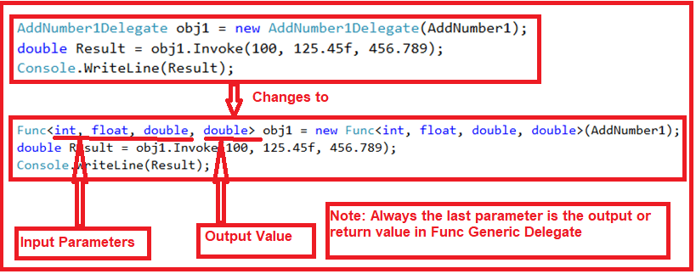

As shown in the above image, the **Func Generic Delegate** takes four parameters, the first three are input parameters and the last one is the return value. To the **Func Generic Delegate** constructor, we pass **the AddNumber1** method which is going to execute when we invoke the Func delegate.

###### **Let’s see how to use the Action Generic Delegate in C#. Have a look at the below image.**

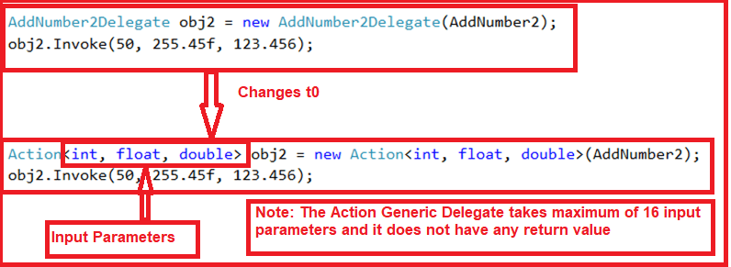

As shown in the above image, the **Action Generic Delegate** takes three input parameters. To the **Action Generic Delegate** constructor, we pass the **AddNumber2** method which is going to execute when we invoke the Action delegate.

###### **Let’s see how to use the Predicate Generic Delegate in C#. Have a look at the below image.**

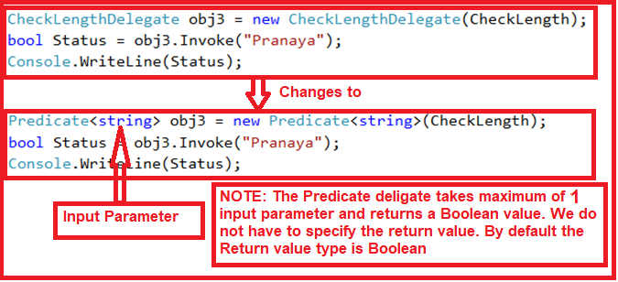

As shown in the above image, the **Predicate Generic Delegate** takes one string input parameter. To the **Predicate Generic Delegate** constructor, we pass the **CheckLength** method which is going to execute when we invoke the Predicate Generic delegate. This delegate can take a maximum of 1 input parameter and 0 return values. By default, it returns a Boolean value.

###### **Below is the complete code.**

**namespace** *GenericDelegateDemo***{**

**public** **class** GenericDelegates**{**

**static** **void** Main**(**string**[]** args**){**

Func**<int**, **float**, **double**, **double>** obj1 = new Func**<int**, **float**, **double**, **double>(**AddNumber1**)**;

**double** Result = obj1.Invoke**(**100, 125.45f, 456.789**)**;

Console.WriteLine**(**Result**)**;

Action**<int**, **float**, **double>** obj2 = new Action**<int**, **float**, **double>(**AddNumber2**)**;

obj2.Invoke**(**50, 255.45f, 123.456**)**;

Predicate**<**string**>** obj3 = new Predicate**<**string**>(**CheckLength**)**;

**bool** Status = obj3.Invoke**(**"Pranaya"**)**;

Console.WriteLine**(**Status**)**;

Console.ReadKey**()**;

**}**

**public** **static** **double** AddNumber1**(int** no1, **float** no2, **double** no3**){**

**return** no1+ no2 + no3;**}**

**public** **static** **void** AddNumber2**(int** no1, **float** no2, **double** no3**){**

Console.WriteLine**(** no1 + no2 + no3**)**;**}**

**public** **static** **bool** CheckLength**(**string name**){**

**if** **(**name.Length **>** 5**)**

**return** **true**;

**return** **false**;

**}**

**}**

**}**

###### **OUTPUT:**

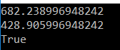

**Singleton pattern**

This type of design pattern comes under creational pattern, as it provides one of the best ways to create an object.

This pattern ensures that a class has only one instance and provides a global point of access to it.

A Singleton should be used when managing access to a resource, which is shared by the entire Application or we can say when we want to make a centralized global object.

**Description**

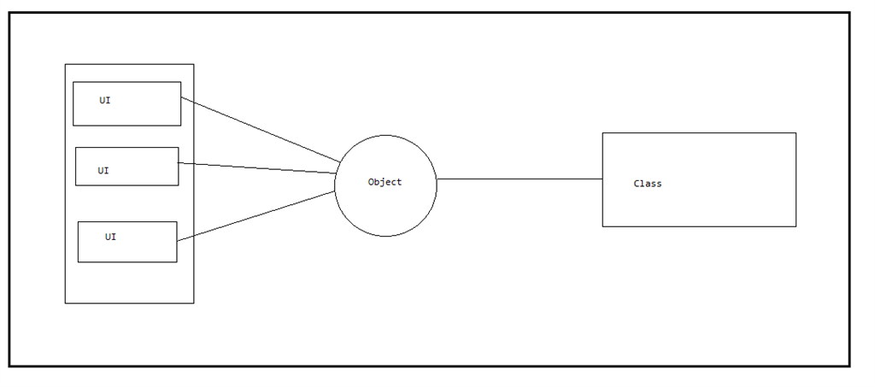

In Singleton pattern only one object is created for the class and that object is shared across all the clients, this approach is used when we want to make something centralized. This approach is used in creating a logged file for the whole Application. This is because, whatever error is generated for all the clients, we need to track it from a single file. Thus, we need a singleton pattern here.

In this case, if we follow singlecall (one object for each UI) approach, there is a chance of removing the first user errors from the file, when the second user encounters some error, and here only the second user error will be logged in the logged file.

To implement Singleton pattern in our project, we have to follow three main steps, which are-

* Declare a private constructor for the class for which you want to make Singleton.
* Declare a static variable for that class.
* Create a static method for that class and assign the object to the declared static variable.

**Private Constructor**

1. A private constructor cannot be inherited. If you try to inherit a private constructor, it will give the error and one more important point about the private constructor is if you want to create an object of the class, it will give an error and hence does not allow you to create an object.
   1. **using** System;
   2. **using** System.Collections.Generic;
   3. **using** System.Linq;
   4. **using** System.Text;
   5. **using** System.Threading.Tasks;
   7. **namespace** oops1
   8. {
   9. **public** **class** Toyota
   10. {
   12. **private** Toyota()
   13. {
   14. }
   15. }
   16. **public** **class** Mycar:Toyota
   17. {
   18. **static** **void** Main(**string**[] args)
   19. {
   21. Console.ReadLine();
   22. }
   23. }
   24. }

It will show the error message, given below-  
  
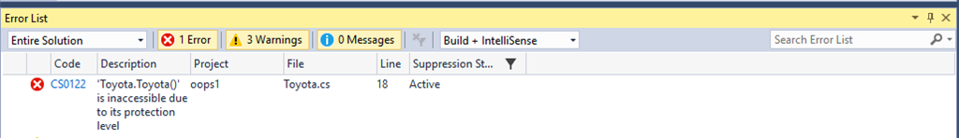

1. Now the question is, how will we consume the members of a class that has a private constructor. Thus, if we are taking a private constructor for a class, we have to declare all the members of the class as static. This is because the static member of a class can be called or consumed by only the class name.
   1. **using** System;
   2. **using** System.Collections.Generic;
   3. **using** System.Linq;
   4. **using** System.Text;
   5. **using** System.Threading.Tasks;
   7. **namespace** oops1
   8. {
   9. **public** **class** Toyota
   10. {
   11. **private** Toyota()
   12. {
   13. }
   14. **public** **static** **string** name;
   15. **public** **static** **string** getData()
   16. {
   17. **return** name;
   18. }
   19. }
   20. **public** **class** Mycar
   21. {
   22. **static** **void** Main(**string**[] args)
   23. {
   24. Toyota.name = "India";
   25. Console.WriteLine(Toyota.name);
   26. Console.ReadLine();
   27. }
   28. }
   29. }

Thus, we have seen the importance of Private constructor. This private constructor plays an important role in singleton pattern in any language.

Now, we will see, how to implement Singleton pattern, using private constructor. I am doing one Console Application to make use of Singleton pattern, given below-

1. **public** **class** Toyota
2. {
3. **private** Toyota()
4. {
5. }
6. **public** **static** Toyota obj;
7. **public** **static** Toyota GetInstance()
8. {
9. **if**(obj==**null**)
10. {
11. obj = **new** Toyota();
12. }
13. **return** obj;
14. }
15. **public** **string** getDetails()
16. {
17. **return** "India";
18. }
19. }

Here, I have designed this class as singleton class. Here, I have taken one static variable and one static method as GetInstance. I am checking whether an object is null or not. When the Application starts for the first time, the value will be null and then it will contain some value until the end of the programme and would not execute the if condition and thus does not create the object.

Now, call from another class.  
  
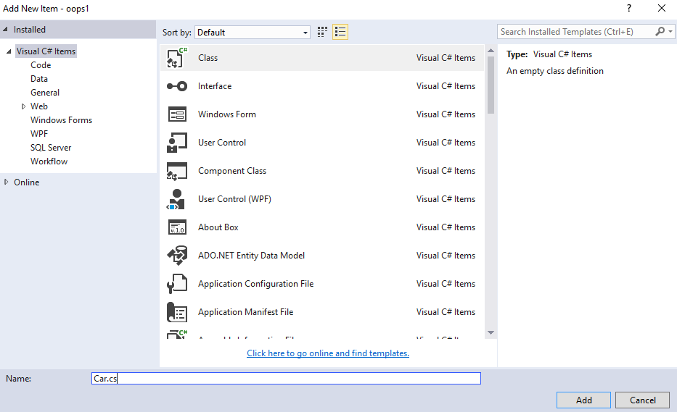

1. **using** System;
2. **using** System.Collections.Generic;
3. **using** System.Linq;
4. **using** System.Text;
5. **using** System.Threading.Tasks;
7. **namespace** oops1
8. {
9. **public** **class** Car
10. {
12. **static** **void** Main(**string**[] args)
13. {
14. Toyota toy = Toyota.GetInstance();
15. **string** x= toy.getDetails();
16. Console.WriteLine(x);
17. Console.ReadLine();
18. }
19. }
20. }

The implementation here is straightforward. The constructor of Toyota is private. Thus, it is not possible to instantiate it from outside. The only way to get an instance is to call static GetInstance() method. GetInstance() first checks, whether an instance is already created or not. If not, then it creates an instance, refersit via private static member instance and then returns it. If already created, it returns the previously created instance. Thus, the first call GetInstance() instantiates a Toyota object only and any further call returns the same object. Also note, the object is not instantiated until GetInstance() is called, i.e. we only create, when actually required.

Now, I can create one more object like-

1. **static** **void** Main(string[] args)
2. {
3. Toyota toy = Toyota.GetInstance();
4. Toyota toy1 =Toyota.GetInstance();
5. string x= toy.getDetails();
6. Console.WriteLine(x);
7. Console.ReadLine();
8. }

 In this case, even if we will try to create a new object, it will not execute the if condition and gives up the first object.

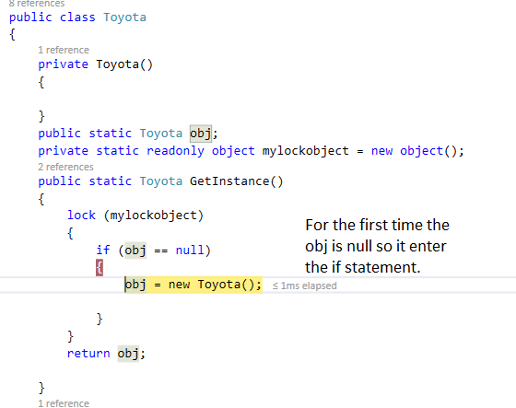

For another object, this obj!=null now and and it will not go to execute the condition.  
  
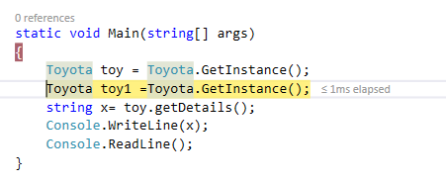  
  
This is how it fails to the condition and gives the first object reference.  
  
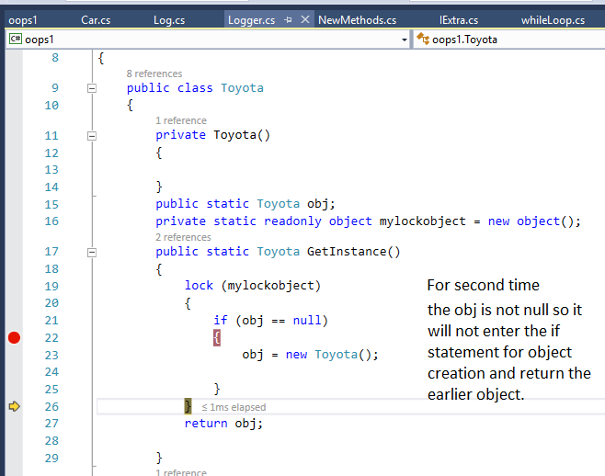   
  
In this way, we can implement Singleton pattern in our project. Now, the main concept is about handling multiple request in Singleton pattern.

**Implementation of Thread-safe Singleton Design Pattern in C# using locks.**

Let us discuss how to implement the Thread-safe Singleton Design Pattern in C# using locks to handle the multithreaded environment. The point that you need to remember is Locks are the best option to handle the singleton instance,

Using locks we can synchronize the method. So that only one thread can access it at any given point of time. In the following code, we lock the shared resource and then checks whether the instance is created or not. If the instance is already created then we simply return that instance else we will create the instance and then return that instance.

As we have seen before, the above is not thread-safe. Two different threads could both have evaluated the test if (obj==null) and found it to be true, and create both the instances, which violate the Singleton pattern. Note, in fact, the instance may already have been created before the expression is evaluated, but the memory model doesn't guarantee that the new value of instance will be seen by other threads unless suitable memory barriers have been passed.

Thus, I have written the following program for thread safe environments.

1. **using** System;
2. **using** System.Collections.Generic;
3. **using** System.Linq;
4. **using** System.Text;
5. **using** System.Threading.Tasks;
7. **namespace** oops1
8. {
9. **public** **class** Toyota
10. {
11. **private** Toyota()
12. {
14. }
15. **public** **static** Toyota obj;
16. **private** **static** **readonly** **object** mylockobject = **new** **object**();
17. **public** **static** Toyota GetInstance()
18. {
19. **lock** (mylockobject)
20. {
21. **if** (obj == **null**)
22. {
23. obj = **new** Toyota();
24. }
25. }
26. **return** obj;
27. }
28. **public** **string** getDetails()
29. {
30. **return** "India";
31. }
32. }
33. }

Here, the output is produced, when we will call the method.

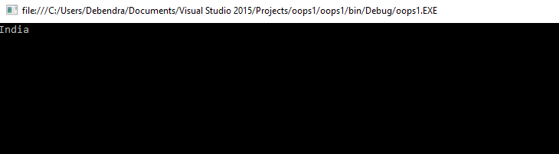

**Why use Repository Parretn**

The Repository pattern is used to decouple the business logic and the data access layers in your application.

The data access layer typically contains storage specific code and methods to operate on the data to and from the data storage.

The business logic layer of your application need not have any knowledge on how data are storing in DB.

# C# | Generics – Introduction

**Generic**is a class which allows the user to define classes and methods with the placeholder. Generics were added to version 2.0 of the C# language. The basic idea behind using Generic is to allow type (Integer, String, … etc and user-defined types) to be a parameter to methods, classes, and interfaces. A primary limitation of collections is the absence of effective type checking. This means that you can put any object in a collection because all classes in the C# programming language extend from the object base class. This compromises type safety and contradicts the basic definition of C# as a type-safe language. In addition, using collections involves a significant performance overhead in the form of implicit and explicit type casting that is required to add or retrieve objects from a collection.

To address the type safety issue, the [**.NET**](https://www.geeksforgeeks.org/c-net-framework-basic-architecture-component-stack/)framework provides generics to create classes, structures, interfaces, and methods that have placeholders for the types they use. Generics are commonly used to create type-safe collections for both reference and value types. The [**.NET**](https://www.geeksforgeeks.org/c-net-framework-basic-architecture-component-stack/) framework provides an extensive set of interfaces and classes in the System.Collections.Generic namespace for implementing generic collections.

**Example:**

|  |
| --- |
| // C# program to show working of  // user defined Generic classes  using System;    // We use < > to specify Parameter type  public class GFG<T> {        // private data members      private T data;        // using properties      public T value      {            // using accessors          get          {              return this.data;          }          set          {              this.data = value;          }      }  }    // Driver class  class Test {        // Main method      static void Main(string[] args)      {            // instance of string type          GFG<string> name = new GFG<string>();          name.value = "GeeksforGeeks";            // instance of float type          GFG<float> version = new GFG<float>();          version.value = 5.0F;            // display GeeksforGeeks          Console.WriteLine(name.value);            // display 5          Console.WriteLine(version.value);      }  } |

**Output :**

GeeksforGeeks

5

**Explanation:** The preceding example defines a generic class, GFG, which uses a generic type parameter ‘T’. In the Main() method, two instances of GFG have been created by replacing ‘T’ with ‘string’ and ‘float’ data types. These objects are used to store ‘string’ and ‘float’ values respectively. The GFG class ensures type safety by accepting the required type in its constructor.

**A Generic method with various parameters:** Just as a method can take one argument, generics can take various parameters. One argument can be passed as a familiar type and other as a generic type, as shown below :

* **Example:**

filter_none

edit

play_arrow

brightness_4

|  |
| --- |
| // C# program to show multiple  // type parameters in Generics  using System;    public class GFG {        // Generics method      public void Display<TypeOfValue>(string msg, TypeOfValue value)      {          Console.WriteLine("{0}:{1}", msg, value);      }  }    // Driver class  public class Example {        // Main Method      public static int Main()      {            // creating object of class GFG          GFG p = new GFG();            // calling Generics method          p.Display<int>("Integer", 122);          p.Display<char>("Character", 'H');          p.Display<double>("Decimal", 255.67);          return 0;      }  } |

**Output :**

Integer:122

Character:H

Decimal:255.67

**Advantages of Generics**

* **Reusability:**You can use a single generic type definition for multiple purposes in the same code without any alterations. For example, you can create a generic method to add two numbers. This method can be used to add two integers as well as two floats without any modification in the code.
* **Type Safety:**Generic data types provide better type safety, especially in the case of collections. When using generics you need to define the type of objects to be passed to a collection. This helps the compiler to ensure that only those object types that are defined in the definition can be passed to the collection.
* **Performance:**Generic types provide better performance as compared to normal system types because they reduce the need for boxing, unboxing, and typecasting of variables or objects.

**Why we did not define static method in interface**

An interface is a contract that a type guarantees to implement. To use the contract you'll need an instance of the type. Static members are not applied to an instance but shared across all instances. Therefore a static member on an interface doesn't make sense because you could never call it. Additionally an interface itself has no code, it's just a type definition. In order to have a static member space would need to be allocated to store the code. That isn't how interfaces work.

**Volatile keyword in C#**

The volatile keyword **indicates that a field might be modified by multiple threads that are executing at the same time**. The compiler, the runtime system, and even hardware may rearrange reads and writes to memory locations for performance reasons.

Volatile keyword we used very rarely in C# but when we work on the multi threading environment that time we need this keyword to solve the one issue.

Suppose we have below code.

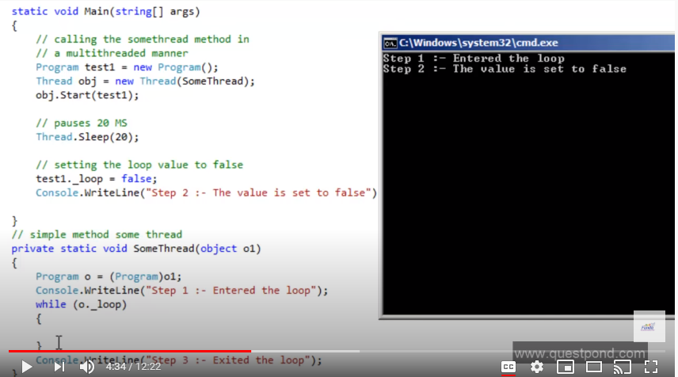

-As per the above code when Thread.Sleep(20) will execute it will sleep the first thread and start the test1 thread and set the _loop variable to false but after that also while loop will not terminated and it’s will not execute to “Step-3 Exited the loop” message.

Below screen will explain the issue.

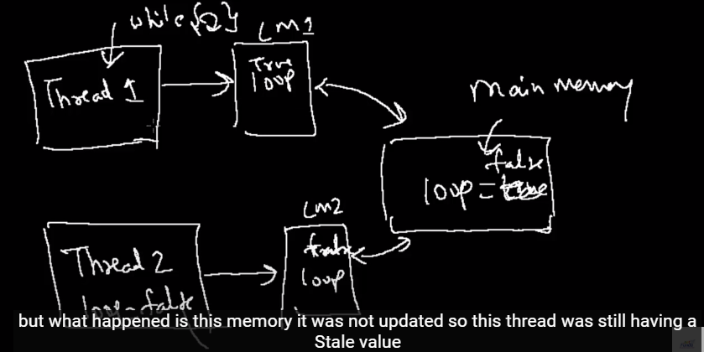

-As per the above screen shot thread 2 will update the _loop variable to false in main memory and his local memory but in thread 1 local memory still it’s value is true that is the reason it’s not terminating the loop.

-So to fix that issue we will use the volatile keyword to sync the _loop value in local memory once it’s change.

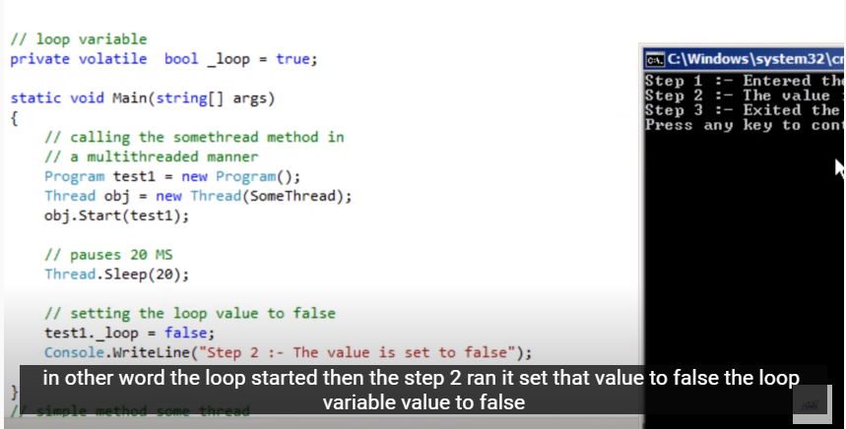

**Unmanaged Code in C#**

-Code which is not managed by .Net framework (CLR) is called the unmanaged code.

Unmanaged code are handled by the operating system.

-Developer need to manage the memory for unmanaged code using the dispose and using block. Like:- FileStream

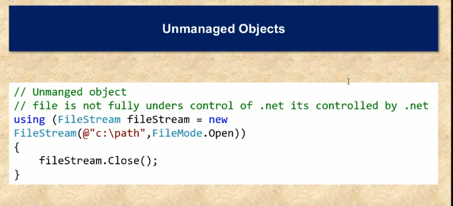

-In above code example @”c:\path” file is handled by the operating system so that is called unmanaged code.

**Difference b/w static and singleton in C#**

1-Static is a keyword where as singleton is a design pattern.

2-Singleton Objects stored on heap while static class stored in stack.

3-Singleton Objects can have constructor while Static Class can have static constructor only.

4-Singleton Objects can dispose but not static class.

5-Singleton Objects can clone but not with static class.

6-A Singleton can implement interfaces, inherit from other classes and allow

inheritance. While a static class cannot inherit their instance members & we can not

implement interface in the static class.

7-A static class allows only static methods where in singleton class we can define static as well as not

static member.

**Abstraction in C#**

Hiding the implementation and just showing the functionality to user is called the abstraction. It is not necessary to implement the abstraction using the abstract class it is also possible to implement the abstraction without using the abstract class like method call in emirates system in ASConnect project, add() method ,console.writeLine().

Below Example for using the abstract class

// C# program to calculate the area

// of a square using the concept of

// data abstraction

using System;

namespace Demoabstraction {

// abstract class

abstract class Shape {

// abstract method

public abstract int area();

}

// square class inherting

// the Shape class

class Square : Shape {

// private data member

private int side;

// method of square class

public Square(int x = 0)

{

side = x;

}

// overriding of the abstract method of Shape

// class using the override keyword

public override int area()

{

Console.Write("Area of Square: ");

return (side * side);

}

}

// Driver Class

class GFG {

// Main Method

static void Main(string[] args)

{

// creating reference of Shape class

// which refer to Square class instance

Shape sh = new Square(4);

// calling the method

double result = sh.area();

Console.Write("{0}", result);

}

}

}

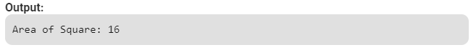

**What is TDD**

TDD is a methodology which says, write your tests first before you write your code. In TDD, tests drive your application design and development cycles. You do not do the check-in of your code into source control until all of your unit tests pass.

**What is BDD**

Behavioral Driven Development (BDD) is a software development approach that has evolved from [TDD](https://blog.testlodge.com/what-is-tdd/) (Test Driven Development). It differs by being written in a shared language, which improves communication between tech and non-tech teams and stakeholders. In both development approaches, tests are written ahead of the code, but in BDD, tests are more user-focused and based on the system’s behavior.

**NUnit Testing Framework**

NUnit is a unit-testing framework for .NET applications in which the entire application is isolated into diverse modules. Each module is tested independently to ensure that the objective is met. The NUnit Framework caters to a range of attributes that are used during unit tests. They are used to define Test -Fixtures, Test methods, ExpectedException, and Ignore methods.

**TextFixture Attribute**

The TestFixture attribute is an indication that a class contains test methods. When you mention this attribute to a class in your project, the Test Runner application will scan it for test methods. The following code illustrates the usage of this attribute as in the following

1. using System;
2. using NUnit.Framework;
3. using System.Text;
4. namespace UNitTesting {
5. [TestFixture]
6. **public** **class** Program {}
7. }

**Test Attribute**

The Test attribute indicates that a method within a test fixture should be run by the Test Runner application. The method must be public, return void, and will not be run when the Test Fixture is run. The following code depicts the use of this attribute as in the following

1. [TestFixture]
2. **public** **class** Program {
3. [Test]
4. **public** **void** Test() { ...
5. }
6. }

**Assert Class**

the Assert class is used to confirm whether the test cases are producing the expected result or not using its auxiliary methods such as AreEqual() or AreNotEqual().

**ExpectedException Attribute**

You could fortify your code to handle various exceptions by using try...Catch blocks. But sometimes you have some circumstances where you actually want to ensure that an exception occurs. To overcome such a problem you should use the ExpectedException attribute as in the following

1. [TestFixture]
2. **public** **class** Program {
3. [Test]
4. [ExpectedException(**typeof**(DivideByZeroException))]
5. **public** **void** Test() {
6. **int** i = 10, j = 0, x;
7. x = i / j;
8. }
9. }

In the previous code, we are intentionally committing a divide by zero exception that is to be detected during the NUnit Test execution.

**Ignore Attribute**

The Ignore attribute is required to indicate that a test should not be run on a particular method. Use the Ignore attribute as in the following:

1. [TestFixture]
2. **public** **class** Program
3. {
4. [Test]
5. [Ignore("This method is skipping")]
6. **public** **void** Test()
7. {
8. ...
9. }
10. }

# Garbage Collection in C# | .NET Framework

Automatic memory management is made possible by **Garbage Collection in .NET Framework**. When a class object is created at runtime, certain memory space is allocated to it in the heap memory. However, after all the actions related to the object are completed in the program, the memory space allocated to it is a waste as it cannot be used. In this case, garbage collection is very useful as it automatically releases the memory space after it is no longer required.

**Example of Ref and Out**

Ref Keyword

The ref keyword passes arguments by reference. It means any changes made to this argument in the method will be reflected in that variable when control returns to the calling method.

**Example code**

1. **public** **static** string GetNextName(ref **int** id)
2. {
3. string returnText = "Next-" + id.ToString();
4. id += 1;
5. **return** returnText;
6. }
7. **static** **void** Main(string[] args)
8. {
9. **int** i = 1;
10. Console.WriteLine("Previous value of integer i:" + i.ToString());
11. string test = GetNextName(ref i);
12. Console.WriteLine("Current value of integer i:" + i.ToString());
13. }

**Output**



Out Keyword

The out keyword passes arguments by reference. This is very similar to the ref keyword.

**Example Code**

1. **public** **static** string GetNextNameByOut(out **int** id)
2. {
3. id = 1;
4. string returnText = "Next-" + id.ToString();
5. **return** returnText;
6. }
7. **static** **void** Main(string[] args)
8. {
9. **int** i = 0;
10. Console.WriteLine("Previous value of integer i:" + i.ToString());
11. string test = GetNextNameByOut(out i);
12. Console.WriteLine("Current value of integer i:" + i.ToString());
13. }

**Output**



**Shall we define static constructor in Static class**

-yes we can define static constructor in static class as well as non-static class.

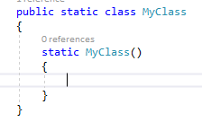

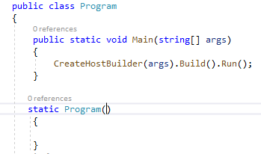

Order of the constructor execute when define static constructor in both parent & child class

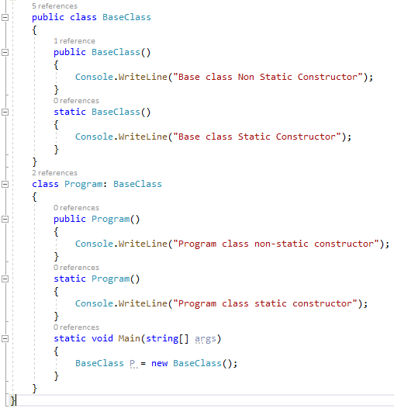

Output when creating the object of Program Class

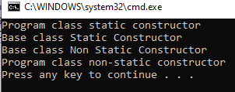

Output when creating the object of Base Class

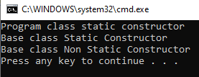

# Lazy Loading in C#

Lazy loading is a concept where we delay the loading of the object until the point where we need it. Putting in simple words, on demand object loading rather than loading objects unnecessarily.

Have a look at the following code.

namespace ConsoleAPP

{

    public class PersonalLoan

    {

        public string AccountNumber { get; set; }

        public string AccounHolderName { get; set; }

        public Loan LoanDetail { get; set; }

        public PersonalLoan(string accountNumber)

        {

            this.AccountNumber = accountNumber;

            this.AccounHolderName = "Sourav";

            this.LoanDetail = new Loan(this.AccountNumber);

        }

    }

    public class Loan

    {

        public string AccountNumber { get; set; }

        public float LoanAmount { get; set; }

        public bool IsLoanApproved { get; set; }

        public Loan(string accountNumber)

        {

            Console.WriteLine("Loan loading started");

            this.AccountNumber = accountNumber;

            this.LoanAmount = 1000;

            this.IsLoanApproved = true;

            Console.WriteLine("Loan loading started");

        }

    }

    class Program

    {

        static void Main(string[] args)

        {

            PersonalLoan p = new PersonalLoan("123456");

            Console.ReadLine();

        }

    }

}

This is not lazy loading since we are seeing that the LoadDetail property is being populated at the time of PersonalLoan object creation. If object creation of LoanDetail is very costly then it will be a very time and resource intensive operation to create an object of a PersonalLoad class.

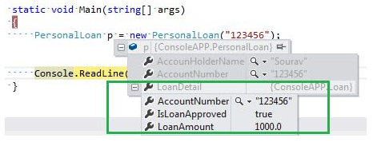

Ok, somehow we will implement a mechanism to populate the LoadDetail property in delay, I mean if needed we will populate the property otherwise not.  
  
It can solve our problem and obviously it will improve performance in the application. Have a look at the following example. We can see that the LoanDetail property will not be populated when an object of the PersonalLoan class is created.

namespace ConsoleAPP

{

    public class PersonalLoan

    {

        public string AccountNumber { get; set; }

        public string AccounHolderName { get; set; }

        public Loan LoanDetail { get; set; }

        public PersonalLoan(string accountNumber)

        {

            this.AccountNumber = accountNumber;

            this.AccounHolderName = "Sourav";

        }

    }

    public class Loan

    {

        public string AccountNumber { get; set; }

        public float LoanAmount { get; set; }

        public bool IsLoanApproved { get; set; }

        public Loan(string accountNumber)

        {

            Console.WriteLine("Loan loading started");

            this.AccountNumber = accountNumber;

            this.LoanAmount = 1000;

            this.IsLoanApproved = true;

            Console.WriteLine("Loan loading started");

        }

    }

    class Program

    {

        static void Main(string[] args)

        {

            PersonalLoan p = new PersonalLoan("123456");

            //Load Detail started to load

            p.LoanDetail = new Loan("123456");

            Console.WriteLine(p.LoanDetail.AccountNumber);

            Console.WriteLine(p.LoanDetail.IsLoanApproved);

            Console.WriteLine(p.LoanDetail.LoanAmount);

            Console.ReadLine();

        }

    }

}

So, we are seeing that the LoanDetail Property is still null. As soon as we load the property in our code , it will be populated.  
  
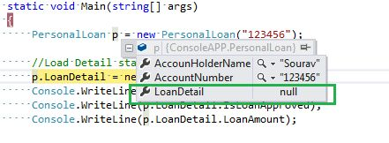

**Implement lazy loading using Lazy<T> class**

As we know, lazy loading is a nice feature of applications, not only to improve the performance of the application but also it helps to manage memory and other resource efficiently. Basically we can use lazy initialization when a large object is created or the execution of a resource- intensive task in particular when such creation or execution might not occur during the lifetime of the program.  
  
And there are many choices to implement lazy initialization. We can use our own implementation to delay object population or we can use the Lazy<T> class of the .NET library to do it.

To prepare for lazy initialization, you create an instance of Lazy<T>. The type argument of the Lazy<T> object that you create specifies the type of the object that you want to initialize lazily. The constructor that you use to create the Lazy<T> object determines the characteristics of the initialization. Lazy initialization occurs the first time the Lazy<T>.Value property is accessed.

The Lazy<T> class contains two properties by which we can detect the status of the lazy class.

**IsValueCreated**  
  
This property will tell us whether or not the value is initializing in a lazy class.

**Value**  
  
It gets the lazy initialized value of the current Lazy<T> instance.

Fine. We will now implement one simple class and we will see how lazy<T> works with it. Have a look at the following example.

namespace ConsoleAPP

{

    public class Test

    {

        private List<string> list = null;

        public Test()

        {

            Console.WriteLine("List Generated:");

            list = new List<string>() {

                "Sourav","Ram"

            };

        }

        public List<string> Names

        {

            get

            {

                return list;

            }

        }

    }

    class Program

    {

        static void Main(string[] args)

        {

            Lazy<Test> lazy = new Lazy<Test>();

            Console.WriteLine("Data Loaded : " + lazy.IsValueCreated);

            Test t = lazy.Value;

            foreach (string tmp in t.Names)

            {

                Console.WriteLine(tmp);

            }

            Console.ReadLine();

        }

    }

}

The Test class has been declared and the instance (lazy) has created a Lazy<T> class. We are then checking whether the value is populated or not in the Test class. In the output we are seeing the value is “False” so, the value is still not populated.

Whenever the line “Test t = lazy.Value” executes, the value will be populated in the Test class and this is how the Test class will initialize lazily.

In the next line we are accessing the property of the test class that will return a string array and we are printing it. Here is sample output in the following.  
  
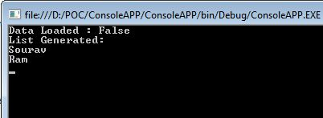

The question may occur to you, is lazy<T> thread safe ?  
  
By default, all public and protected members of the Lazy<T> class are thread safe and may be used concurrently from multiple threads. These thread-safety guarantees may be removed optionally and per instance, using parameters to the type's constructors.

# Eager Loading in Entity Framework

Eager Loading helps you to load all your needed entities at once; i.e., all your child entities will be loaded at single database call. This can be achieved, using the Include method, which returs the related entities as a part of the query and a large amount of data is loaded at once.

For Ecxample:

class Program {

static void Main(string[] args) {

using (var context = new UniContextEntities()) {

// Load all students and related enrollments

var students = context.Students

.Include(s ⇒ s.Enrollments).ToList();

foreach (var student in students) {

string name = student.FirstMidName + " " + student.LastName;

Console.WriteLine("ID: {0}, Name: {1}", student.ID, name);

foreach (var enrollment in student.Enrollments) {

Console.WriteLine("Enrollment ID: {0}, Course ID: {1}",

enrollment.EnrollmentID, enrollment.CourseID);

}

}

Console.ReadKey();

}

}

}

When the above code is compiled and executed you will receive the following output.

ID: 1, Name: Ali Alexander

Enrollment ID: 1, Course ID: 1050

Enrollment ID: 2, Course ID: 4022

Enrollment ID: 3, Course ID: 4041

ID: 2, Name: Meredith Alonso

Enrollment ID: 4, Course ID: 1045

Enrollment ID: 5, Course ID: 3141

Enrollment ID: 6, Course ID: 2021

ID: 3, Name: Arturo Anand

Enrollment ID: 7, Course ID: 1050

ID: 4, Name: Gytis Barzdukas

Enrollment ID: 8, Course ID: 1050

Enrollment ID: 9, Course ID: 4022

### Multiple Levels

It is also possible to eagerly load multiple levels of related entities. The following queries show examples of Student, Enrollments and Course.

// Load all Students, all related enrollments, and all related courses

var studentList = context.Students

.Include(s ⇒ s.Enrollments.Select(c ⇒ c.Course)).ToList();

// Load all Students, all related enrollments, and all related courses

// using a string to specify the relationships

var students = context.Students

.Include("Enrollments.Course").ToList();

Can we define constructor in abstract class

-Yes

Shall we define a class as private,protected,protectedInternal in C#

-Simply NO. Nothing unless it’s in a nested Class

-Classes and structs that are not nested within other classes or structs can be either **public** or **internal**. A type declared as public is accessible by any other type. A type declared as internal is only accessible by types within the same assembly. Classes and structs are declared as **internal by default** unless the keyword public is added to the class definition.

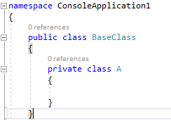

Shall we define static method with the same signature in Parent and child class?

-Yes this is possible without any error

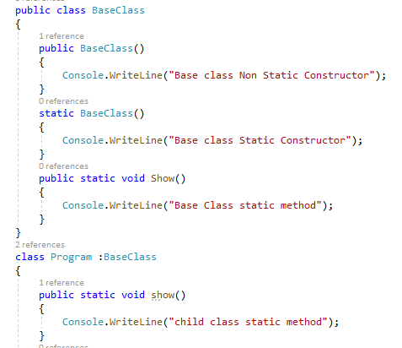

**How to improve the performance of the application if page loading is taking time**

Below are some step we need to follow for improve the performance of the application

-Check for eager loading or lazy loading properly and implement same based on the requirement if some data is not needed(like child model data) at the time of loading the page then use the lazy loading otherwise use the eager loading

-Need to use the js or css file as a building so we will send all the file in single request and get the response also in single request.

-Check for the image size which will take the more time to load the data and try to use the comprise image.

-use the linq query in place of loop.

**What are the generation of Garbage Collection in C# .NET ?**

When an object is first created, it is put into generation 0. When the generation 0 is filled up, the garbage collector is invoked. The objects that survive the garbage collection in the first generation are promoted onto the next higher generation, generation 1. The objects that survive garbage collection in generation 1 are promoted onto the next and the highest generation, generation 2. This algorithm works efficiently for garbage collection of objects, as it is fast. Note that generation 2 is the highest generation that is supported by the garbage collector.

The heap is organized into generations so it can handle long-lived and short-lived objects. Garbage collection primarily occurs with the reclamation of short-lived objects that typically occupy only a small part of the heap. There are three generations of objects on the heap: •Generation 0. This is the youngest generation and contains short-lived objects. An example of a short-lived object is a temporary variable. Garbage collection occurs most frequently in this generation. Newly allocated objects form a new generation of objects and are implicitly generation 0 collections, unless they are large objects, in which case they go on the large object heap in a generation 2 collection.Most objects are reclaimed for garbage collection in generation 0 and do not survive to the next generation. •Generation 1. This generation contains short-lived objects and serves as a buffer between short-lived objects and long-lived objects. •Generation 2. This generation contains long-lived objects. An example of a long-lived object is an object in a server application that contains static data that is live for the duration of the process.

# C# Params

In C#, **params** is a keyword which is used to specify a parameter that takes variable number of arguments. It is useful when we don't know the number of arguments prior. Only one params keyword is allowed and no additional parameter is permitted after params keyword in a function declaration.

**Example**

The following example demonstrates various ways in which arguments can be sent to a params parameter.

public class MyClass

{

public static void UseParams(params int[] list)

{

for (int i = 0; i < list.Length; i++)

{

Console.Write(list[i] + " ");

}

Console.WriteLine();

}

public static void UseParams2(params object[] list)

{

for (int i = 0; i < list.Length; i++)

{

Console.Write(list[i] + " ");

}

Console.WriteLine();

}

static void Main()

{

UseParams(1, 2, 3, 4);

UseParams2(1, 'a', "test");

// A params parameter accepts zero or more arguments.

// The following calling statement displays only a blank line.

UseParams2();

// An array argument can be passed, as long as the array

// type matches the parameter type of the method being called.

int[] myIntArray = { 5, 6, 7, 8, 9 };

UseParams(myIntArray);

object[] myObjArray = { 2, 'b', "test", "again" };

UseParams2(myObjArray);

}

}

/*

Output:

1 2 3 4

1 a test

5 6 7 8 9

2 b test again

System.Int32[]

*/

**IOC container in .Net Framework for implement dependency injection**

Unity

StructureMap

Castle Windsor

Ninject

Autofac

DryIoc

Simple Injector

Light Inject

**Where to use the delegates in real time**

-Delegates are mainly used for the event handling and the callback methods.

Callback Example

-First create the delegates and pass that delegates as a method parameter for callback functionality like below.

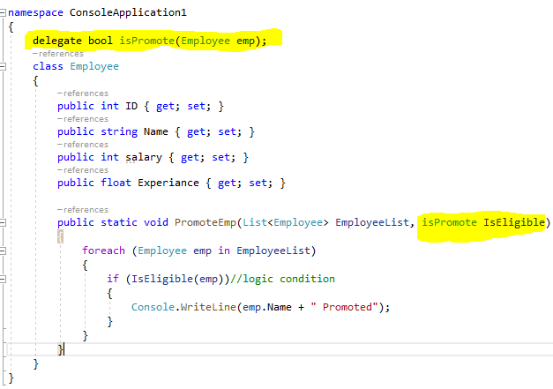

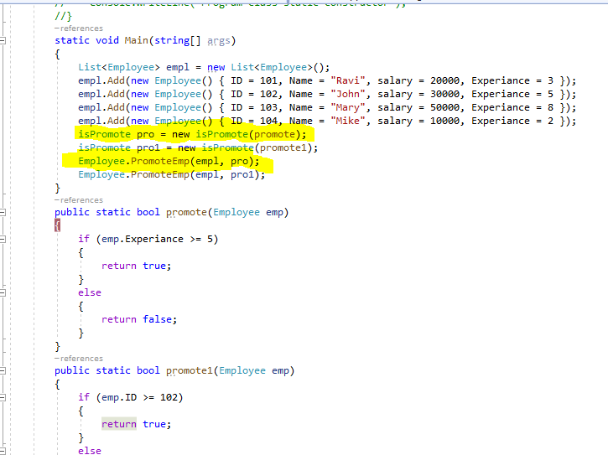

Event Handler Example

An event is a notification sent by an object to signal the occurrence of an action.

The class who raises events is called Publisher, and the class who receives the notification is called Subscriber. There can be multiple subscribers of a single event. Typically, a publisher raises an event when some action occurred. The subscribers, who are interested in getting a notification when an action occurred, should register with an event and handle it.

In C#, an event is an encapsulated [delegate](https://www.tutorialsteacher.com/csharp/csharp-delegates). It is dependent on the delegate. The [delegate](https://www.tutorialsteacher.com/csharp/csharp-delegates) defines the signature for the event handler method of the subscriber class.

The following figure illustrates the event in C#.

[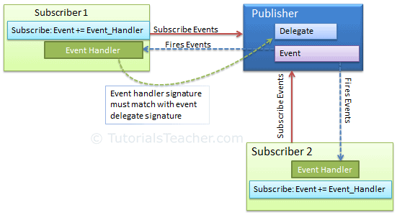](https://www.tutorialsteacher.com/Content/images/csharp/event-model.png)

Declare an Event

An event can be declared in two steps:

1. Declare a delegate.
2. Declare a variable of the delegate with event keyword.

The following example shows how to declare an event in publisher class.

1. Example: Declaring an Event
2. public delegate void Notify(); // delegate
4. public class ProcessBusinessLogic
5. {
6. public event Notify ProcessCompleted; // event
7. }

In the above example, we declared a delegate Notify and then declared an event ProcessCompleted of delegate type Notify using "event" keyword in the ProcessBusinessLogic class. Thus, the ProcessBusinessLogic class is called the publisher. The Notify delegate specifies the signature for the ProcessCompleted event handler. It specifies that the event handler method in subscriber class must have a void return type and no parameters.

Now, let's see how to raise the ProcessCompleted event. Consider the following implementation.

Example: Raising an Event

public delegate void Notify(); // delegate

public class ProcessBusinessLogic

{

public event Notify ProcessCompleted; // event

public void StartProcess()

{

Console.WriteLine("Process Started!");

// some code here..

OnProcessCompleted();

}

protected virtual void OnProcessCompleted() //protected virtual method

{

//if ProcessCompleted is not null then call delegate

ProcessCompleted?.Invoke();

}

}

Above, the StartProcess() method calls the method onProcessCompleted() at the end, which raises an event. Typically, to raise an event, protected and virtual method should be defined with the name On<EventName>. Protected and virtual enable derived classes to override the logic for raising the event. However, A derived class should always call the On<EventName> method of the base class to ensure that registered delegates receive the event.

The OnProcessCompleted() method invokes the delegate using ProcessCompleted?.Invoke();. This will call all the event handler methods registered with the ProcessCompleted event.

The subscriber class must register to ProcessCompleted event and handle it with the method whose signature matches Notify delegate, as shown below.

Full Example

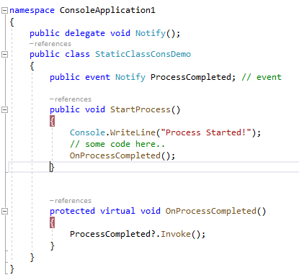

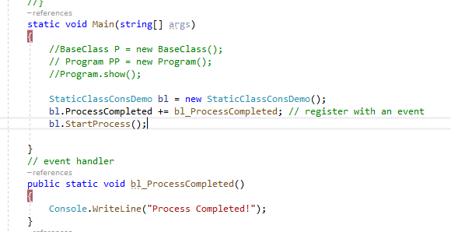

Output



## Built-in EventHandler Delegate

.NET Framework includes built-in delegate types [EventHandler](https://docs.microsoft.com/en-us/dotnet/api/system.eventhandler) and [EventHandler<TEventArgs>](https://docs.microsoft.com/en-us/dotnet/api/system.eventhandler-1) for the most common events. Typically, any event should include two parameters: the source of the event and event data. Use the EventHandler delegate for all events that do not include event data. Use [EventHandler<TEventArgs>](https://docs.microsoft.com/en-us/dotnet/api/system.eventhandler-1) delegate for events that include data to be sent to handlers.

The example shown above can use EventHandler delegate without declaring a custom Notify delegate, as shown below.

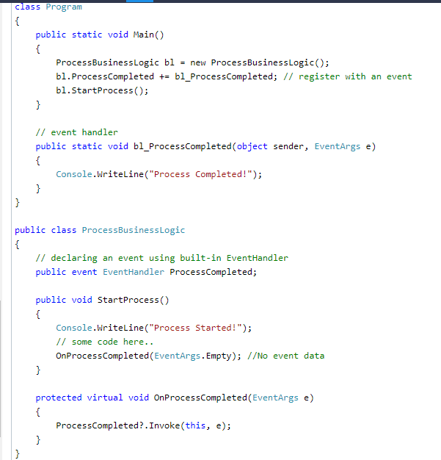

Output



## Passing an Event Data

Most events send some data to the subscribers. The [EventArgs](https://docs.microsoft.com/en-us/dotnet/api/system.eventargs) class is the base class for all the event data classes. .NET includes many built-in event data classes such as [SerialDataReceivedEventArgs](https://docs.microsoft.com/en-us/dotnet/api/system.io.ports.serialdatareceivedeventargs). It follows a naming pattern of ending all event data classes with EventArgs. You can create your custom class for event data by deriving EventArgs class.

Use [EventHandler<TEventArgs>](https://docs.microsoft.com/en-us/dotnet/api/system.eventhandler-1) to pass data to the handler, as shown below.

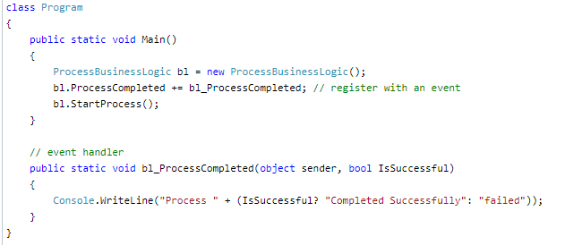

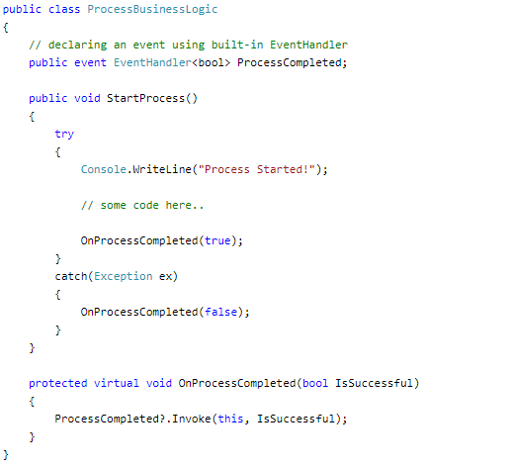

Output

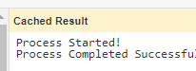

# C# Enumerations Type – Enum

In C#, an enum (or enumeration type) is used to assign constant names to a group of numeric integer values. It makes constant values more readable, for example, WeekDays.Monday is more readable then number 0 when referring to the day in a week.

An enum is defined using the enum keyword, directly inside a namespace, class, or structure. All the constant names can be declared inside the curly brackets and separated by a comma. The following defines an enum for the weekdays.

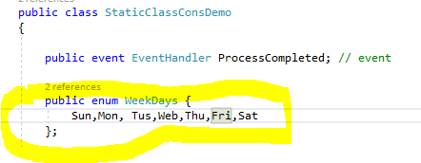

Enum Values

If values are not assigned to enum members, then the compiler will assign integer values to each member starting with zero by default. The first member of an enum will be 0, and the value of each successive enum member is increased by 1.

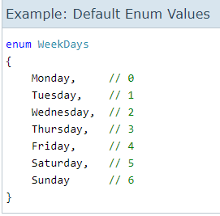

You can assign different values to enum member. A change in the default value of an enum member will automatically assign incremental values to the other members sequentially.

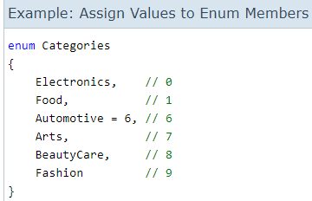

You can even assign different values to each member.

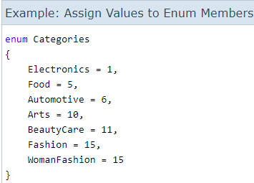

The enum can be of any numeric data type such as byte, sbyte, short, ushort, int, uint, long, or ulong. However, an enum cannot be a string type.

Specify the type after enum name as : type. The following defines the byte enum.

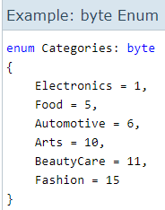

Access an Enum

An enum can be accessed using the dot syntax: enum.member

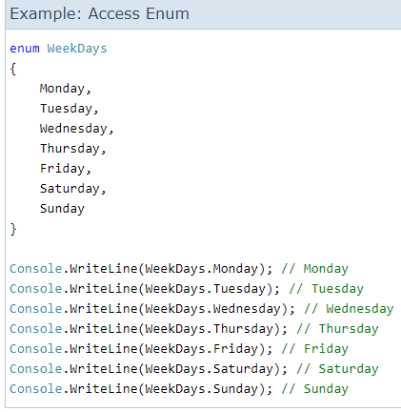

Conversion

Explicit casting is required to convert from an enum type to its underlying integral type.

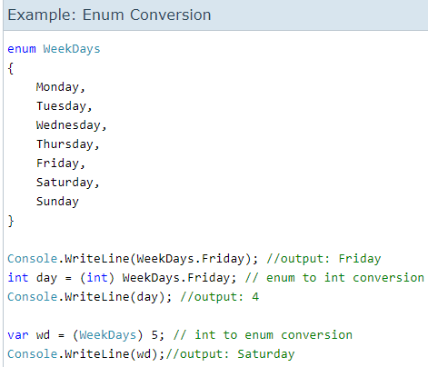

**C# Code Compile process**

The Code Execution Process involves the following two stages:

1. Compiler time process.
2. Runtime process.

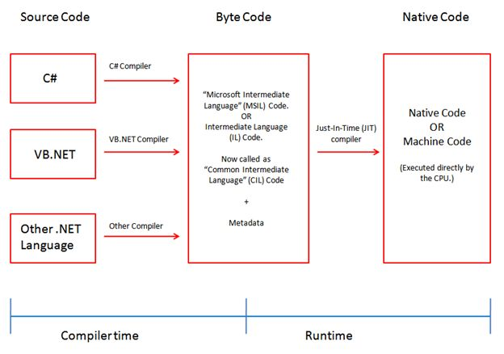

**What is an assembly**

An assembly is the building block of code. It is basically compiled code that can be executed by the CLR. An Assembly can be a DLL or exe depending upon the project that we choose. All the .NET assemblies contain the definition of types, versioning information for the type, meta-data, and manifest.

Assemblies are basically the following two types:

1. Private Assembly
2. Shared Assembly
3. **Private Assembly**  
     
   It is an assembly that is being used by a single application only. Suppose we have a project in which we refer to a DLL so when we build that project that DLL will be copied to the bin folder of our project. That DLL becomes a private assembly within our project. Generally the DLLs that are meant for a specific project are private assemblies.

**2. Shared Assembly**  
  
Assemblies that can be used in more than one project are known to be a shared assembly. Shared assemblies are generally installed in the GAC. Assemblies that are installed in the GAC are made available to all the .Net applications on that machine.  
  
However there are two more types of assemblies in .Net, Satellite Assembly and Shared Assembly.

**GAC**  
GAC stands for Global Assembly Cache. It is a memory that is used to store the assemblies that are meant to be used by various applications.  
  
Every computer that has CLR installed must have a GAC. GAC is a location that can be seen at “C:\Windows\assembly” for .Net applications with frameworks up to 3.5. For higher frameworks like 4 and 4.5 the GAC can be seen at:  
“C:\Windows\Microsoft.NET\assembly\GAC_MSIL”.

**Installing an assembly into the GAC**  
For installing an assembly into the GAC we first need to generate strong names for the assembly because only a strong name assembly is installed in the GAC. All other assemblies are known as weak named assemblies and they cannot be stored in the GAC.  
  
For generating a strong name assembly we first create a console application type project. In that solution we will add one more project (Class Library).  
  
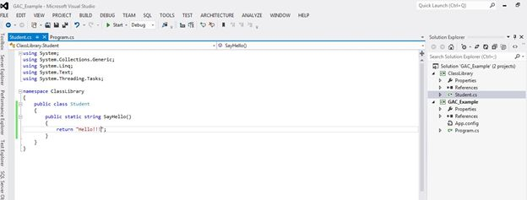

In the Class Library project I created a class Student that contains a method that returns a string. Now I will add a reference of the Class Library to my Console application project and will use this method.  
  
If we see the bin folder of our Console Application project then we will see that the ClassLibrary DLL is present there (It will come when we build our project). This DLL is a Private Assembly now.  
  


**Generating Strong Name**

To make our assembly strongly named we need to generate a unique key value pair, for that we need to open the Visual Studio command prompt. We can open that from the Start button by going to "All programs" -> "Visual Studio 2012" (or any version that you have)  -> "Visual Studio Tools" -> "Developer Command Prompt for Visual Studio" and run that as an administrator.

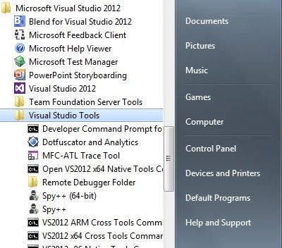

Then type the command sn –k “Path where you want that key to be generated”

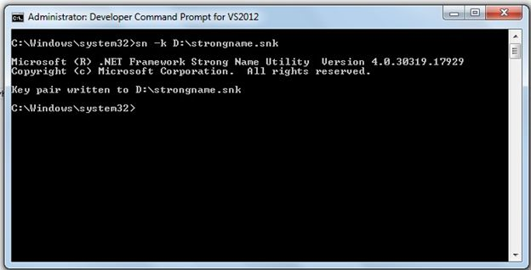  
  
This will generate the unique key pair that we will use in our application.  
  
Now move to the Visual Studio Class Library Project and open the AssemblyInfo.cs file that is residing in the Properties folder of your project. In the bottom of that file add a new attribute that refers to the key pair file that we have just created.

[assembly: AssemblyKeyFile("D:\\strongname.snk")]

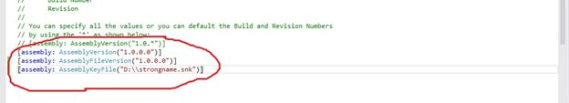  
  
Now build your Class Library project and ensure it builds successfully. If it builds then it means that your ClassLibrary DLL has become strongly typed. If you want to check that then open the Visual Studio command prompt, copy the path of the "bin.Debug" folder of your ClassLibrary project. Now paste the path into the command prompt with the cd command (refer to the following screenshot). Now type the command sn –T “ClassLibrary.dll”. After typing this command you will get a public key token that indicates that your assembly is Strongly Named and it is ready to install in the GAC.

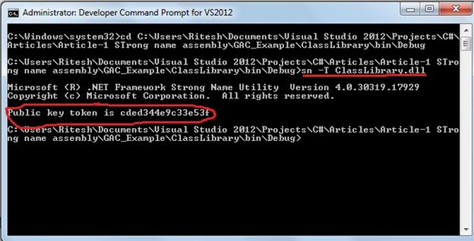  
  
Now to install the assembly in the cache type the following command in the command prompt:  
  
gacutil –i "Name of the Class Library"

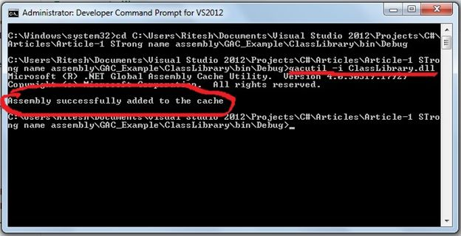  
  
Now the Assembly is successfully installed on the system. If you want to see that you can see that in the location “C:\Windows\Microsoft.NET\assembly\GAC_MSIL”.  
  
**Note**: If you are using the framework greater than 4.0 then you can search the preceding given path but if you are using a framework lesser than 4.0 then your assembly will be installed at “C:\Windows\assembly”.

 vola

